The Right Reverend Andrew ML. Dietsche, Bishop
The Right Reverend Allen Kunho Shin, Bishop Suffragan
The Right Reverend Mary Glasspool, Assistant Bishop
The Reverend Dr. Chip Graves, Rector
The Reverend Adolfo Moronta, Associate Priest
Peter Roberts, Director of Music of Grace Church
Juan Carlos Abreu, Director of Music of La Gracia
Donna Louis, Youth Ministry Coordinator
Suzan Ortega-Collado, Administrator
Taurino Juárez, Sexton
All Saints Day
November 1, 2020
33 Church Street
White Plains, New York 10601
914-949-2874
www.gracewhiteplains.org
VESTRY MEMBERS
Michael Heffner Senior. Warden
Daisy Calderon, Junior Warden
Hillary Fleming, Treasurer
Irene Alves, Clerk
Class of 2020: Hillary Fleming, Michael Heffner, Daisy Calderon
Class of 2021: Irene Alves, Sorraya Sampson Elliott, Eileen McClean
Class of 2022 Mary Baker, Daniel Corsanego, Edythe Horne, Charlotte Roberson
Grace Church is a diverse congregation committed to a common life sustained by worship.
We bear witness to God’s love in Christ through our life together and our service to the wider
community.

All Saints Day
November 1, 2020
Our Liturgy may be found in the Book of Common Prayer beginning on page 355.
HOLY EUCHARIST

Prelude: Prelude on Rhosymedre R. V. Williams

Please stand.
Hymn #287 For all the saints Ross Keiser
1 For all the saints who from their labors rest,
who thee by faith before the world confessed,
thy name, O Jesus, be forever blest.
Alleluia! Alleluia!
2 Thou wast their rock, their fortress, and their might;
thou, Lord, their captain in the well-fought fight;
thou, in the darkness drear, their one true light.
Alleluia! Alleluia!
3 O may thy soldiers, faithful, true, and bold,
fight as the saints who nobly fought of old,
and win with them the victor's crown of gold.
Alleluia! Alleluia!
4 O blest communion, fellowship divine,
we feebly struggle, they in glory shine;
yet all are one in thee, for all are thine.
Alleluia! Alleluia!
5 And when the fight is fierce, the warfare long,
steals on the ear the distant triumph song,
and hearts are brave again, and arms are strong.
Alleluia! Alleluia!
6 The golden evening brightens in the west;
soon, soon to faithful warrior cometh rest;
sweet is the calm of paradise the blest.
Alleluia! Alleluia!
7 But lo! there breaks a yet more glorious day;
the saints triumphant rise in bright array;
the King of glory passes on his way.
Alleluia! Alleluia!
8 From earth's wide bounds, from ocean's farthest coast,
through gates of pearl streams in the countless host,
singing to Father, Son, and Holy Ghost,
Alleluia! Alleluia!

Celebrant Blessed be God: Father, Son and Holy Spirit.
People And blessed be His kingdom, now and forever.
Collect BCP 355
Almighty God, to you all hearts are open, all desires known, and from you no secrets are hid: Cleanse the thoughts of our hearts by the inspiration of your Holy Spirit, that we may perfectly love you, and worthily magnify your holy Name; through Christ our Lord. Amen

Gloria
Glory to God in the highest,
and peace to his people on earth.
Lord God, heavenly King,
almighty God and Father,
we worship you, we give you thanks,
we praise you for your glory.
Lord Jesus Christ, only Son of the Father,
Lord God, Lamb of God,
you take away the sin of the world:
have mercy on us;
you are seated at the right hand of the Father:
receive our prayer.
For you alone are the Holy One,
you alone are the Lord,
you alone are the Most High,
Jesus Christ,
with the Holy Spirit,
in the glory of God the Father. Amen.
Collect of the Day
Priest: The Lord Be With You
Response: And Also With You

Almighty God, you have knit together your elect in one communion and fellowship in the mystical body of your Son Christ our Lord: Give us grace so to follow your blessed saints in all virtuous and godly living, that we may come to those ineffable joys that you have prepared for those who truly love you; through Jesus Christ our Lord, who with you and the Holy Spirit lives and reigns, one God, in glory everlasting. Amen.

THE WORD OF GOD

Please be seated.

Revelation 7:9-17
After this I, John, looked, and there was a great multitude that no one could count, from every nation, from all tribes and peoples and languages, standing before the throne and before the Lamb, robed in white, with palm branches in their hands. They cried out in a loud voice, saying,
"Salvation belongs to our God who is seated on the throne, and to the Lamb!" And all the angels stood around the throne and around the elders and the four living creatures, and they fell on their faces before the throne and worshiped God, singing,
"Amen! Blessing and glory and wisdom
and thanksgiving and honor
and power and might
be to our God forever and ever! Amen."
Then one of the elders addressed me, saying, "Who are these, robed in white, and where have they come from?" I said to him, "Sir, you are the one that knows." Then he said to me, "These are they who have come out of the great ordeal; they have washed their robes and made them white in the blood of the Lamb.
"For this reason they are before the throne of God,
and worship him day and night within his temple,
and the one who is seated on the throne will shelter them.
They will hunger no more, and thirst no more;
the sun will not strike them,
nor any scorching heat;
for the Lamb at the center of the throne will be their shepherd,
and he will guide them to springs of the water of life,
and God will wipe away every tear from their eyes."

The Word of the Lord
Thanks be to God.

Psalm 34:1-10,22
Benedicam Dominum
1 I will bless the Lord at all times; *his praise shall ever be in my
mouth.
2 I will glory in the Lord; *let the humble hear and rejoice.
3 Proclaim with me the greatness of the Lord; *let us exalt his Name
together.
4 I sought the Lord, and he answered me *and delivered me out of all
my terror.
5 Look upon him and be radiant, *and let not your faces be ashamed.
6 I called in my affliction and the Lord heard me *and saved me from all
my troubles.
7 The angel of the Lord encompasses those who fear him, *and he will
deliver them.
8 Taste and see that the Lord is good; *happy are they who trust in
him!
9 Fear the Lord, you that are his saints, *for those who fear him lack
nothing.
10 The young lions lack and suffer hunger, *but those who seek
the Lord lack nothing that is good.
22 The Lord ransoms the life of his servants, *and none will be
punished who trust in him.

1 John 3:1-3
See what love the Father has given us, that we should be called children of God; and that is what we are. The reason the world does not know us is that it did not know him. Beloved, we are God's children now; what we will be has not yet been revealed. What we do know is this: when he is revealed, we will be like him, for we will see him as he is. And all who have this hope in him purify themselves, just as he is pure.

The Word of the Lord
Thanks be to God

Please Stand
Matthew 5:1-12

The Holy Gospel of our Lord Jesus Christ according to Matthew

People Glory to you, Lord Christ.
When Jesus saw the crowds, he went up the mountain; and after he sat down, his disciples came to him. Then he began to speak, and taught them, saying:
"Blessed are the poor in spirit, for theirs is the kingdom of heaven.
"Blessed are those who mourn, for they will be comforted.
"Blessed are the meek, for they will inherit the earth.
"Blessed are those who hunger and thirst for righteousness, for they will be filled.
"Blessed are the merciful, for they will receive mercy.
"Blessed are the pure in heart, for they will see God.
"Blessed are the peacemakers, for they will be called children of God.
"Blessed are those who are persecuted for righteousness' sake, for theirs is the kingdom of heaven.
"Blessed are you when people revile you and persecute you and utter all kinds of evil against you falsely on my account. Rejoice and be glad, for your reward is great in heaven, for in the same way they persecuted the prophets who were before you."
The Gospel of the Lord.
People Praise to You Lord Christ.
Please be seated.

The Sermon Rev. Adolfo Moronta, Assoc. Priest.

The Nicene Creed BCP 358

We believe in one God,
the Father, the Almighty,
maker of heaven and earth,
of all that is, seen and unseen.
We believe in one Lord,
Jesus Christ, the only Son of God,
eternally begotten of the Father,
God from God, Light from Light,
true God from true God,

begotten, not made,
of one Being with the Father.
Through him all things were made.
For us and for our salvation
he came down from heaven:

by the power of the Holy Spirit
he became incarnate from the Virgin Mary,
and was made man.
For our sake he was crucified under Pontius Pilate;
he suffered death and was buried.
On the third day he rose again
in accordance with the Scriptures;
he ascended into heaven
and is seated at the right hand of the Father.
He will come again in glory to judge the living and the dead,
and his kingdom will have no end.

We believe in the Holy Spirit, the Lord, the giver of life,
who proceeds from the Father and the Son.
With the Father and the Son he is worshiped and glorified.
He has spoken through the Prophets.
We believe in one holy catholic and apostolic Church.
We acknowledge one baptism for the forgiveness of sins.
We look for the resurrection of the dead,
and the life of the world to come. Amen

The Prayers of the People
With thanksgiving for the gift of new life, and in hope that our risen Savior may fill us with complete joy of his glorious and life-giving resurrection.
Let us pray to our Creator
In Christ our Risen Savior
In thanksgiving for the gift of the Good News, and in hope that the church may find new life in the joyful mystery of the resurrection, especially through the leadership of our Presiding Bishop, Michael Curry, our Bishops Andrew, Allen, and Mary, our priests Fr. Chip and Fr. Adolfo and the lay leaders of this congregation,
Let us pray to our Creator
In Christ our Risen Savior

With thanksgiving for the gift of new life, and in hope that our risen Savior may fill us with the joy of his glorious and life-giving resurrection.
Let us pray to our Creator
In Christ our Risen Savior
In thanksgiving for this community of Grace La Gracia, in hope that God may continue to renew us in his love and guide us,
Let us pray to our Creator
In Christ our Risen Savior
In thanksgiving for the abundance, we enjoy with our families and friends, and in hope that he may provide for those who lack food, work, or shelter,
Let us pray to our Creator
In Christ our Risen Savior
In thanksgiving for the freedoms, we enjoy, and in hope that by his power, war and famine may cease through all the world,
Let us pray to our Creator
In Christ our Risen Savior
In thanksgiving for our health and in hope that he may reveal the light of his presence to comfort and strengthen those who are weak in body and soul, especially those we name silently or aloud,
Let us pray to our Creator
In Christ our Risen Savior
In thanksgiving for the gift of eternal life, and in hope that he may enfold in his joyful presence those who have died and those we now name, silently or aloud, Pause
Let us pray to our Creator
In Christ our Risen Savior
In thanksgiving for the gift of faith, and in hope that God may send the fire of the Holy Spirit upon his people, so that we may bear faithful witness to his resurrection,
Let us pray to our Creator
In Christ our Risen Savior
Priest: O God, worker of wonders, you made this season for joy and gladness. Let the risen Lord abide with us always, set our hearts on fire, and open our eyes, so that we may see him at this table, the Christ now entered into glory, firstborn from the dead. Amen.
The Peace
Please be seated.

Announcements

The Offertory

Hymn Shall We Gather At The River (Arranged by Aaron Copland)
Ross Keiser, soloist

1 Shall we gather at the river,
Where bright angel feet have trod;
With its crystal tide forever
Flowing by the throne of God?
Refrain:
Yes, we'll gather at the river,
The beautiful, the beautiful river;
Gather with the saints at the river
That flows by the throne of God.

2 On the margin of the river,
Washing up its silver spray,
We will walk and worship ever,
All the happy golden day. [Refrain]

3 Ere we reach the shining river,
Lay we ev'ry burden down;
Grace our spirits will deliver,
And provide a robe and crown. [Refrain]

4 Soon we'll reach the shining river,
Soon our pilgrimage will cease;
Soon our happy hearts will quiver
With the melody of peace. [Refrain]

THE HOLY COMMUNION
Eucharistic Prayer A BCP 361

The Lord be with you.
And also with you.

Lift up your hearts.
We lift them to the Lord.
Let us give thanks to the Lord our God.
It is right to give him thanks and praise.

It is right, and a good and joyful thing, always and everywhere to give thanks to you, Father Almighty, Creator of heaven and earth. For in the multitude of your saints you have surrounded us with a great cloud of witnesses, that we might rejoice in their fellowship, and run with endurance the race that is set before us; and, together with them, receive the crown of glory that never fades away.

Sanctus and Benedictus Barrie Cabena
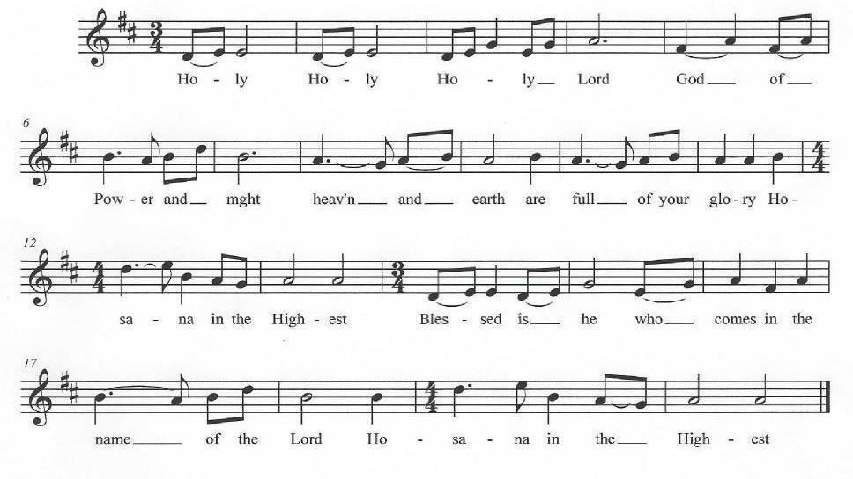

Holy and gracious Father: In your infinite love you made us for yourself, and, when we had fallen into sin and become subject to evil and death, you, in your mercy, sent Jesus Christ, your only and eternal Son, to share our human nature, to live and die as one of us, to reconcile us to you, the God and Father of all. He stretched out his arms upon the cross, and offered himself, in obedience to your will, a perfect sacrifice for the whole world.

On the night he was handed over to suffering and death, our Lord Jesus Christ took bread; and when he had given thanks to you, he broke it, and gave it to his disciples, and said, "Take, eat: This is my Body, which is given for you. Do this for the remembrance of me."

After supper he took the cup of wine; and when he had given thanks, he gave it to them, and said, "Drink this, all of you: This is my Blood of the new Covenant, which is shed for you and for many for the forgiveness of sins. Whenever you drink it, do this for the remembrance of me.”

Therefore we proclaim the mystery of faith:
Celebrant and people:

Christ has died.
Christ is risen.
Christ will come again

We celebrate the memorial of our redemption, O Father, in this sacrifice of praise and thanksgiving. Recalling his death, resurrection, and ascension, we offer you these gifts. Sanctify them by your Holy Spirit to be for your people the Body and Blood of your Son, the holy food and drink of new and unending life in him. Sanctify us also that we may faithfully receive this holy Sacrament, and serve you in unity, constancy, and peace; and at the last day bring us with all your saints into the joy of your eternal kingdom.

All this we ask through your Son Jesus Christ: By him, and with him, and in him, in the unity of the Holy Spirit all honor and glory is yours, Almighty Father, now and forever. Amen.

The Lord’s Prayer

And now, as our Savior Christ has taught us, we are bold to say,

People and Celebrant

Our Father, who art in heaven,
hallowed be thy Name,
thy kingdom come,
thy will be done,
on earth as it is in heaven.

Give us this day our daily bread.
And forgive us our trespasses,
as we forgive those
who trespass against us.
And lead us not into temptation,
but deliver us from evil.
For thine is the kingdom,
and the power, and the glory,
for ever and ever. Amen.

The Breaking of the Bread
Alleluia, Christ our Passover is sacrificed for us.
Therefore let us keep the feast. Alleluia

Angus Dei Barry Cabena
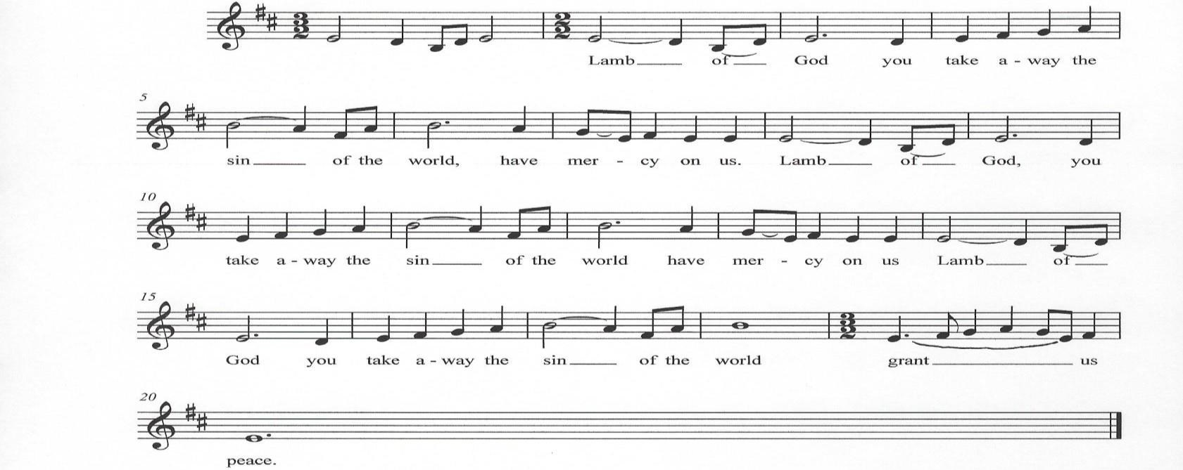

The Invitation
The Gifts of God for the People of God.
The presider invites the following prayer to be said by all:

My Jesus, I believe that you are truly present in the Blessed Sacrament of the Altar. I desire to offer you praise and thanksgiving as I proclaim your resurrection. I love you above all things, and long for you in my soul. Since I cannot receive you in the Sacrament of your Body and Blood, come spiritually into my heart. Cleanse and strengthen me with your grace, Lord Jesus, and let me never be separated from you. May I live in you, and you in me, in this life and in the life to come. Amen.

Post Communion Prayer BCP 365

Eternal God, heavenly Father,
you have graciously accepted us as living members
of your Son our Savior Jesus Christ,
and you have fed us with spiritual food
in the Sacrament of his Body and Blood.
Send us now into the world in peace,
and grant us strength and courage
to love and serve you
with gladness and singleness of heart;
through Christ our Lord. Amen.

The Blessing

May God, to whose glory we celebrate this festival of all the Saints, be now and evermore your guide and companion in the way. Amen.

May God, who has bound us together in the company of the elect, in this age and the age to come, attend to the prayers of his faithful servants on your behalf, as he hears your prayers for them. Amen.

May God, who has given us, in the lives of his saints, patterns of holy living and victorious dying, strengthen your faith and devotion, and enable you to bear witness to the truth against all adversity.
Amen.
Dismissal

Hymn #526 Let saints on earth Ross Keiser
1 Let saints on earth in concert sing
with those whose work is done;
for all the servants of our King
in heaven and earth are one.
2 One family, we dwell in him,
one church, above, beneath;
though now divided by the stream,
the narrow stream of death.
3 One army of the living God,
to his command we bow:
part of the host have crossed the flood,
and part are crossing now.
4 E'en now to their eternal home
there pass some spirits blest;
while others to the margin come,
waiting their call to rest.
5 Jesu, be thou our constant guide;
then, when the word is given,
bid Jordan's narrow stream divide,
and bring us safe to heaven.
Dismissal
Go in peace to love and serve the Lord. Alleluia, Alleluia, Alleluia.
Postlude: Adagio Edward Elgar

Remembrance on All Saints’ Sunday
Eternal God, you have always taken men and women of every nation, age, and color and
made them saints;
like them, transformed, like them, baptized in Jesus’ name, ake us to share in your glory. Amen
[Collect for All Saints Day, New Zealand Prayer Book]
Today we remember with thanksgiving those who have been companions and guides on our faith journey
In Memoriam
We gathered for funerals and memorial services for these members during the past year:
Martha C. Watkins, Verna Brown, Harvey Chambers, Cecil B. Henry, Charles Wiggins, Deacon Martha J. Dunphy, Christopher P. Cox, and Marilyn Scimia.

In Loving Memory of: Remembered By:

Wally | Rodriguez | Nell Plaine
Bill | Sims Jr
Kevin | Stapleton
Stanley | Hutton | Judith Hutton
Rosa | Seawright
Alfred & Katie | Butcher
Arthur & Grace | White
David | Hutton
Edith Helen | Rountree | Charlotte Roberson
Sadye | Barry
Edna | Coggins
Anne | Kascheres
Rudolph | Cammac
Dolores | Savoy
Eugene | Cammac
In Loving Memory of: Remembered By:

Dotlyn Ann | Thomas (beloved Mother & Grandmother) | Margaret Broomfield
Valerie Maria | Williams (beloved Mother & Grandmother)
Elaine | McIntosh (beloved Grandmother)
Tony | Campbell ( beloved friend)
Verna A. | Brown | Joseph R. Brown
Delphine | Brown
Robert M. | Brown
Essie | Rock
Clara | Harmon | Linda Harmon
Richard | Harmon
Marilyn | Scimia
Cerelise | John | Joyce Sampson
Doriis | Ramjohn
Solomon | Ramjohn
Arnott | Sampson
Anthony | Sampson
Nigel | Sampson
Grace | Rerrie-Kelly | Gloria Rerrie-Chang
Barrington | Rerrie
Edward | Rerrie
Mildred | Rerrie
Hurbert | Rerrie
Hortense | Rerrie
Colchier | Sampso
Rev, Canon Percy | Brathwaite | Delores Braithwaite
Esther | Scott
Cole | Scott, Jr
Octavia | Brathwaite
In Loving Memory of: Remembered By:

Corine | Bradley | Brinda Bradley
James | Bradley
Deborah | Bradley
Sakina | Allen
Beverly | Cavahlo
Lelia | Addison
Sampson | Addison
Alice | Terrell
Lester | Terrell
Oscar | Addison
Marie & James | Toney
Carrie & Joe | Richardson
Georgia & Robert | Commander
Thema | Commander - Smith
Dorothy | Addison
Sampson, Jr. & Ruth | Addison
Beatrice | Addison
Jessie | Jenkins
Ophelia | Cuffie
Lucille | Addison
Gussie & Wesley | Bradley
John & Lill | Bradley
Jasper & Rose | Bradley
Wates & Magalene | Bradley
James | Bradley | Sandy Gadsen-McAllister
Corine | Bradley
Deborah | Bradley
William | McAllister
Adriene | Addison-Torres
Mara Jean | Hardin
Charles | Wiggins

Celebrant & Preacher Rev. Fr. Adolfo Moronta, Assoc. Priest
Organist & Choir Director Peter Roberts – Ross Keiser Soloist
If you are visiting with us for the first time, we welcome you to Grace Church!
Our liturgy is found in the Book of Common Prayer. Our communion is open to all baptized Christians. Please take the time to fill out one of our visitor cards which the ushers have available. Your presence is a blessing to us may our worship together be a blessing to you.
Grace Church Prayer List: We hold the following people in prayer: Lee Aldrich, Bernice Burton, Oscar Bunche, Barbara Wiggins, The Family of Charles Wiggins, Cynthia Cole, Family of William J. Davis, Jean Beyer(Fr. Chip’s Father-In-Law), Kimberly Corelli, Darlene and Johnny Peoples, Inez Dale, Carol DiGilio, Bill Dunphy, Cathy Dunphy, Sandra Esannason, Cindy Etheridge, Edmund Dinizo, Gregory Fucci, Laura Fields, Laurie Noone, Sid Fromm, Leigh Burton, Lydia Green, Michael Nissman, Sylvia Howard, Linda Heusser, Jackie Jansky, Evgeniy Kaufman, Nellie King, Nikki Belizze, Manoris Long, Donna Louis, Paxton Louis, Dorothy Lynch, Janice Moore, Nicholas Furmoso (age 7), Selena Perry, Gladstone Reid, Leroy Reid, Renee Reid, Uriel Reid, Al Sargent, Esteban Silvera, Sonia P. Smith, Norman Stanton, Susan Stanton, Dominick Vita, Natasha Vodyanitskaya, Ray Williams
Cedar Manor, Ossining: Robert Auld

Serving in the Armed Forces: Kenny Duffy, Denny J. Edmondson, Christopher P. Halstead, David Packer, Sgt. Christopher Vigliotti, Gunnery Sgt. Les Yearwood

Birthdays – October

2nd James Henderson, Jr. (Biff)
2nd Jayden O. Newman
9th Evelyn D. Delanoy
9th Karen Ann Bunche
14th Biles, Mr. William
15th Michael J. Fischer
16th Aaron Walters
18th Ingrid Richard
22nd Connor B. Lynch
23rd Sylvia L. Simon
25th Dr. Jean-Marie Bradford
27th Kevin Richards
31st Nikolas O’Hanlon

Weddings - October

10/17/2009 Rev. Richard & Barbara Kunz
10/17/1992 Sharon Revan & Gerrard Salmon

Readers

8:00 A.M. Service - Stuart Madden
10:00am – The Reid Family

How to Pledge to Grace/La Gracia 2020

The church will remain flexible in ways to receive your generosity during this difficult period. essings.

Option 1: The standard way of staying current with your pledge still works.

Feel free to put your pledge envelope in the mail (check only) and send it to the Grace Church office (to the attention of the Office
Administrator). Bundling for a few weeks is fine.

Grace Episcopal Church/La Gracia
33 Church Street - 2nd Floor
White Plains, New York 10601

Option 2: Please note that we will be constructing a secure drop box on the red front door of the church. The box will be checked regularly for pledge envelopes (which will be recorded) and gifts of cash.

Option 3: The electronic way to pledge or donate to the church is honestly not very complicated and completely secure. www.gracewhiteplains.org is the link to the Grace/La Gracia website. You'll see a tab across the top for pledging. Click to bring you to the Pledging/Giving page. The "donate" button will take you to the location for electronic giving. The church uses PayPal, the 2019 Fortune 500 payment company (#204 in last year's survey). This service can be used for one time or scheduled payments. One can use credit cards or send funds from a PayPal account (www.paypal.com). Michael Heffner is available to help explain or set up your account - michaelheffner08@gmail.com. Please note that a fee is charged to the church for these transactions (which is why a check in the drop box or sent by mail is always preferred.

The Angelus

The Angelus will be coming out at the beginning of December and all parishioners are welcome to submit items of interest, particularly statements for Views from the Pews about your plans for the holiday season. In view of the Covid pandemic, how will things be different for you this year from past years. Submit before November 15th to: marygene57@msn.com.Flowers

Flowers

During November, Jane Washington has placed flowers on our altar in memory of her parents, Helen Parker Washington and Julian Edward Washington.

.

