The Right Reverend Andrew ML. Dietsche, Bishop
The Right Reverend Allen Kunho Shin, Bishop Suffragan
The Right Reverend Mary Glasspool, Assistant Bishop
The Reverend Dr. Chip Graves, Rector
The Reverend Adolfo Moronta, Associate Priest
Peter Roberts, Director of Music of Grace Church
Juan Carlos Abreu, Director of Music of La Gracia
Donna Louis, Youth Ministry Coordinator
Suzan Ortega-Collado, Administrator
Taurino Juárez, Sexton
The Last Day of Pentecost – Christ the King
November 22, 2020
33 Church Street
White Plains, New York 10601
914-949-2874
www.gracewhiteplains.org
VESTRY MEMBERS
Michael Heffner Senior. Warden
Daisy Calderon, Junior Warden
Hillary Fleming, Treasurer
Irene Alves, Clerk
Class of 2020: Hillary Fleming, Michael Heffner, Daisy Calderon
Class of 2021: Irene Alves, Sorraya Sampson Elliott, Eileen McClean
Class of 2022 Mary Baker, Daniel Corsanego, Edythe Horne, Charlotte Roberson
Grace Church is a diverse congregation committed to a common life sustained by worship.
We bear witness to God’s love in Christ through our life together and our service to the wider
community.

The Last Day of Pentecost – Christ the King
November 22, 2020

Our Liturgy may be found in the Book of Common Prayer beginning on page 355.
HOLY EUCHARIST

Prelude: Aria Handel

Please stand.
Hymn #435 At the Name of Jesus Ross Keiser
1 At the Name of Jesus
every knee shall bow,
every tongue confess him
King of glory now;
'tis the Father's pleasure
we should call him Lord,
who from the beginning
was the mighty Word.
2 Humbled for a season,
to receive a Name
from the lips of sinners,
unto whom he came,
faithfully he bore it
spotless to the last,
brought it back victorious,
when from death he passed;
3 bore it up triumphant,
with its human light,
through all ranks of creatures,
to the central height
to the throne of Godhead,
to the Father's breast;
filled it with the glory
of that perfect rest.
4 Name him, Christians, name him,
with love strong as death,
name with awe and wonder
and with bated breath;
he is God the Saviour,
he is Christ the Lord,
ever to be worshiped,
trusted, and adored.
5 In your hearts enthrone him;
there let him subdue
all that is not holy,
all that is not true:
crown him as your Captain
in temptation's hour;
let his will enfold you
in its light and power.
6 Christians, this Lord Jesus
shall return again,
with his Father's glory,
o'er the earth to reign;
for all wreaths of empire
meet upon his brow,
and our hearts confess him
King of Glory now.

Celebrant Blessed be God: Father, Son and Holy Spirit.
People And blessed be His kingdom, now and forever.
Collect BCP 355
Almighty God, to you all hearts are open, all desires known, and from you no secrets are hid: Cleanse the thoughts of our hearts by the inspiration of your Holy Spirit, that we may perfectly love you, and worthily magnify your holy Name; through Christ our Lord. Amen
Gloria
Glory to God in the highest,
and peace to his people on earth.
Lord God, heavenly King,
almighty God and Father,
we worship you, we give you thanks,
we praise you for your glory.
Lord Jesus Christ, only Son of the Father,
Lord God, Lamb of God,
you take away the sin of the world:
have mercy on us;
you are seated at the right hand of the Father:
receive our prayer.
For you alone are the Holy One,
you alone are the Lord,
you alone are the Most High,
Jesus Christ,
with the Holy Spirit,
in the glory of God the Father. Amen.
Collect of the Day
Priest: The Lord Be With You
Response: And Also With You

Almighty and everlasting God, whose will it is to restore all things in your well-beloved Son, the King of kings and Lord of lords: Mercifully grant that the peoples of the earth, divided and enslaved by sin, may be freed and brought together under his most gracious rule; who lives and reigns with you and the Holy Spirit, one God, now and forever. Amen.

THE WORD OF GOD

Please be seated.

Ezekiel 34:11-16, 20-24
Thus, says the Lord God: I myself will search for my sheep, and will seek them out. As shepherds seek out their flocks when they are among their scattered sheep, so I will seek out my sheep. I will rescue them from all the places to which they have been scattered on a day of clouds and thick darkness. I will bring them out from the peoples and gather them from the countries, and will bring them into their own land; and I will feed them on the mountains of Israel, by the watercourses, and in all the inhabited parts of the land. I will feed them with good pasture, and the mountain heights of Israel shall be their pasture; there they shall lie down in good grazing land, and they shall feed on rich pasture on the mountains of Israel. I myself will be the shepherd of my sheep, and I will make them lie down, says the Lord God. I will seek the lost, and I will bring back the strayed, and I will bind up the injured, and I will strengthen the weak, but the fat and the strong I will destroy. I will feed them with justice.
Therefore, thus says the Lord God to them: I myself will judge between the fat sheep and the lean sheep. Because you pushed with flank and shoulder, and butted at all the weak animals with your horns until you scattered them far and wide, I will save my flock, and they shall no longer be ravaged; and I will judge between sheep and sheep.
I will set up over them one shepherd, my servant David, and he shall feed them: he shall feed them and be their shepherd. And I, the Lord, will be their God, and my servant David shall be prince among them; I, the Lord, have spoken.

The Word of the Lord
Thanks be to God.

Psalm 95:1-7a
Venite, exultemus
1 Come, let us sing to the Lord; *let us shout for joy to the Rock of our
salvation.
2 Let us come before his presence with thanksgiving *and raise a loud
shout to him with psalms.
3 For the Lord is a great God, *and a great King above all gods.
4 In his hand are the caverns of the earth, *and the heights of the hills
are his also.
5 The sea is his, for he made it, *and his hands have molded the dry
land.
6 Come, let us bow down, and bend the knee, *and kneel before
the Lord our Maker.
7 For he is our God, and we are the people of his pasture and the sheep
of his hand.

Ephesians 1:15-23
I have heard of your faith in the Lord Jesus and your love toward all the saints, and for this reason I do not cease to give thanks for you as I remember you in my prayers. I pray that the God of our Lord Jesus Christ, the Father of glory, may give you a spirit of wisdom and revelation as you come to know him, so that, with the eyes of your heart enlightened, you may know what is the hope to which he has called you, what are the riches of his glorious inheritance among the saints, and what is the immeasurable greatness of his power for us who believe, according to the working of his great power. God put this power to work in Christ when he raised him from the dead and seated him at his right hand in the heavenly places, far above all rule and authority and power and dominion, and above every name that is named, not only in this age but also in the age to come. And he has put all things under his feet and has made him the head over all things for the church, which is his body, the fullness of him who fills all in all.

The Word of the Lord
Thanks be to God

Please Stand
Matthew 25:31-46

The Holy Gospel of our Lord Jesus Christ according to Matthew

People Glory to you, Lord Christ.
Jesus said, “When the Son of Man comes in his glory, and all the angels with him, then he will sit on the throne of his glory. All the nations will be gathered before him, and he will separate people one from another as a shepherd separates the sheep from the goats, and he will put the sheep at his right hand and the goats at the left. Then the king will say to those at his right hand, ‘Come, you that are blessed by my Father, inherit the kingdom prepared for you from the foundation of the world; for I was hungry and you gave me food, I was thirsty and you gave me something to drink, I was a stranger and you welcomed me, I was naked and you gave me clothing, I was sick and you took care of me, I was in prison and you visited me.’ Then the righteous will answer him, ‘Lord, when was it that we saw you hungry and gave you food, or thirsty and gave you something to drink? And when was it that we saw you a stranger and welcomed you, or naked and gave you clothing? And when was it that we saw you sick or in prison and visited you?’ And the king will answer them, ‘Truly I tell you, just as you did it to one of the least of these who are members of my family, you did it to me.’ Then he will say to those at his left hand, ‘You that are accursed, depart from me into the eternal fire prepared for the devil and his angels; for I was hungry and you gave me no food, I was thirsty and you gave me nothing to drink, I was a stranger and you did not welcome me, naked and you did not give me clothing, sick and in prison and you did not visit me.’ Then they also will answer, ‘Lord, when was it that we saw you hungry or thirsty or a stranger or naked or sick or in prison, and did not take care of you?’ Then he will answer them, ‘Truly I tell you, just as you did not do it to one of the least of these, you did not do it to me.’ And these will go away into eternal punishment, but the righteous into eternal life.”
The Gospel of the Lord.
People Praise to You Lord Christ.
Please be seated.

The Sermon The Rev. Chip Graves, Rector

The Nicene Creed BCP 358

We believe in one God,
the Father, the Almighty,
maker of heaven and earth,
of all that is, seen and unseen.
We believe in one Lord,
Jesus Christ, the only Son of God,
eternally begotten of the Father,
God from God, Light from Light,
true God from true God,

begotten, not made,
of one Being with the Father.
Through him all things were made.
For us and for our salvation
he came down from heaven:

by the power of the Holy Spirit
he became incarnate from the Virgin Mary,
and was made man.
For our sake he was crucified under Pontius Pilate;
he suffered death and was buried.
On the third day he rose again
in accordance with the Scriptures;
he ascended into heaven
and is seated at the right hand of the Father.
He will come again in glory to judge the living and the dead,
and his kingdom will have no end.

We believe in the Holy Spirit, the Lord, the giver of life,
who proceeds from the Father and the Son.
With the Father and the Son he is worshiped and glorified.
He has spoken through the Prophets.
We believe in one holy catholic and apostolic Church.
We acknowledge one baptism for the forgiveness of sins.
We look for the resurrection of the dead,
and the life of the world to come. Amen

The Prayers of the People
With thanksgiving for the gift of new life, and in hope that our risen Savior may fill us with complete joy of his glorious and life-giving resurrection.
Let us pray to our Creator
In Christ our Risen Savior
In thanksgiving for the gift of the Good News, and in hope that the church may find new life in the joyful mystery of the resurrection, especially through the leadership of our Presiding Bishop, Michael Curry, our Bishops Andrew, Allen, and Mary, our priests Fr. Chip and Fr. Adolfo and the lay leaders of this congregation,
Let us pray to our Creator
In Christ our Risen Savior

With thanksgiving for the gift of new life, and in hope that our risen Savior may fill us with the joy of his glorious and life-giving resurrection.
Let us pray to our Creator
In Christ our Risen Savior
In thanksgiving for this community of Grace La Gracia, in hope that God may continue to renew us in his love and guide us,
Let us pray to our Creator
In Christ our Risen Savior
In thanksgiving for the abundance, we enjoy with our families and friends, and in hope that he may provide for those who lack food, work, or shelter,
Let us pray to our Creator
In Christ our Risen Savior
In thanksgiving for the freedoms, we enjoy, and in hope that by his power, war and famine may cease through all the world,
Let us pray to our Creator
In Christ our Risen Savior
In thanksgiving for our health and in hope that he may reveal the light of his presence to comfort and strengthen those who are weak in body and soul, especially those we name silently or aloud,
Let us pray to our Creator
In Christ our Risen Savior
In thanksgiving for the gift of eternal life, and in hope that he may enfold in his joyful presence those who have died and those we now name, silently or aloud, Pause
Let us pray to our Creator
In Christ our Risen Savior
In thanksgiving for the gift of faith, and in hope that God may send the fire of the Holy Spirit upon his people, so that we may bear faithful witness to his resurrection,
Let us pray to our Creator
In Christ our Risen Savior
Priest: O God, worker of wonders, you made this season for joy and gladness. Let the risen Lord abide with us always, set our hearts on fire, and open our eyes, so that we may see him at this table, the Christ now entered into glory, firstborn from the dead. Amen.
Priest: Let us confess our sins against God and our neighbor.
Silence may be kept.
Minister and People
Most merciful God,
we confess that we have sinned against you
in thought, word, and deed,
by what we have done,
and by what we have left undone.
We have not loved you with our whole heart;
we have not loved our neighbors as ourselves.
We are truly sorry and we humbly repent.
For the sake of your Son Jesus Christ,
have mercy on us and forgive us;
that we may delight in your will,
and walk in your ways,
to the glory of your Name. Amen.
The Peace
Please be seated.

Announcements

Offertory Anthem
King of glory, King of peace David Charles Walker Ross Keiser

1 King of glory, King of peace,
I will love Thee;
and that love may never cease,
I will move Thee.
Thou hast granted my request,
Thou hast heard me;
Thou didst note my working breast,
Thou hast spared me.
2 Wherefore with my utmost art
I will sing Thee,
and the cream of all my heart
I will bring Thee.
Though my sins against me cried,
Thou didst clear me;
and alone, when they replied,
Thou didst hear me.
3 Sev'n whole days, not one in sev'n,
I will praise Thee;
in my heart, though not in heav'n,
I can raise Thee.
Small it is, in this poor sort
to enroll Thee:
e'en eternity's too short
to extol Thee.
The Offertory
THE HOLY COMMUNION

Eucharistic Prayer A BCP 361

The Lord be with you.
And also with you.

Lift up your hearts.
We lift them to the Lord.
Let us give thanks to the Lord our God.
It is right to give him thanks and praise.

It is right, and a good and joyful thing, always and everywhere to give thanks to you, Father Almighty, Creator of heaven and earth. Through Jesus Christ our Lord; who on the first day of the week overcame death and the grave, and by his glorious resurrection opened to us the way of everlasting life.
Therefore, we praise you, joining our voices with Angels and Archangels and with all the company of heaven, who forever sing this hymn to proclaim the glory of your Name:

Sanctus and Benedictus Barrie Cabena
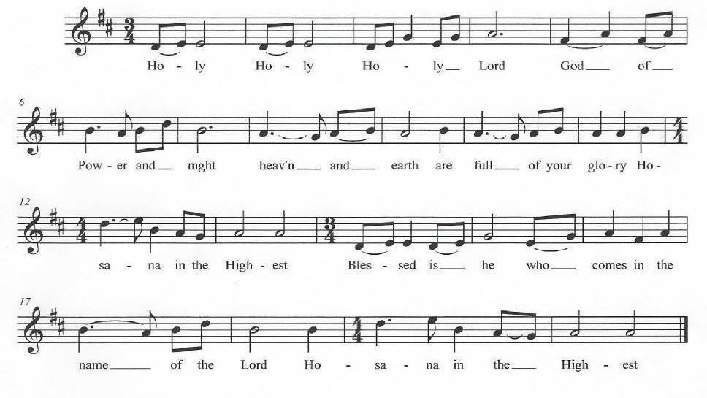

Holy and gracious Father: In your infinite love you made us for yourself, and, when we had fallen into sin and become subject to evil and death, you, in your mercy, sent Jesus Christ, your only and eternal Son, to share our human nature, to live and die as one of us, to reconcile us to you, the God and Father of all. He stretched out his arms upon the cross, and offered himself, in obedience to your will, a perfect sacrifice for the whole world.

On the night he was handed over to suffering and death, our Lord Jesus Christ took bread; and when he had given thanks to you, he broke it, and gave it to his disciples, and said, "Take, eat: This is my Body, which is given for you. Do this for the remembrance of me."

After supper he took the cup of wine; and when he had given thanks, he gave it to them, and said, "Drink this, all of you: This is my Blood of the new Covenant, which is shed for you and for many for the forgiveness of sins. Whenever you drink it, do this for the remembrance of me.”

Therefore we proclaim the mystery of faith:
Celebrant and people:

Christ has died.
Christ is risen.
Christ will come again

We celebrate the memorial of our redemption, O Father, in this sacrifice of praise and thanksgiving. Recalling his death, resurrection, and ascension, we offer you these gifts. Sanctify them by your Holy Spirit to be for your people the Body and Blood of your Son, the holy food and drink of new and unending life in him. Sanctify us also that we may faithfully receive this holy Sacrament, and serve you in unity, constancy, and peace; and at the last day bring us with all your saints into the joy of your eternal kingdom.

All this we ask through your Son Jesus Christ: By him, and with him, and in him, in the unity of the Holy Spirit all honor and glory is yours, Almighty Father, now and forever. Amen.

The Lord’s Prayer

And now, as our Savior Christ has taught us, we are bold to say,

People and Celebrant

Our Father, who art in heaven,
hallowed be thy Name,
thy kingdom come,
thy will be done,
on earth as it is in heaven.

Give us this day our daily bread.
And forgive us our trespasses,
as we forgive those
who trespass against us.
And lead us not into temptation,
but deliver us from evil.
For thine is the kingdom,
and the power, and the glory,
for ever and ever. Amen.

The Breaking of the Bread
Alleluia, Christ our Passover is sacrificed for us.
Therefore let us keep the feast. Alleluia

Angus Dei Barry Cabena
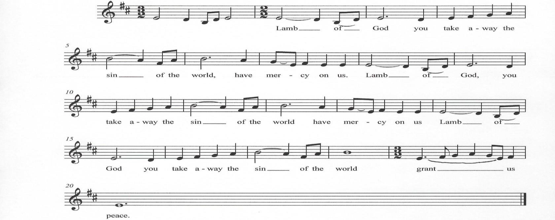

The Invitation
The Gifts of God for the People of God.
The presider invites the following prayer to be said by all:

My Jesus, I believe that you are truly present in the Blessed Sacrament of the Altar. I desire to offer you praise and thanksgiving as I proclaim your resurrection. I love you above all things, and long for you in my soul. Since I cannot receive you in the Sacrament of your Body and Blood, come spiritually into my heart. Cleanse and strengthen me with your grace, Lord Jesus, and let me never be separated from you. May I live in you, and you in me, in this life and in the life to come. Amen.

Post Communion Prayer BCP 365

Eternal God, heavenly Father,
you have graciously accepted us as living members
of your Son our Savior Jesus Christ,
and you have fed us with spiritual food
in the Sacrament of his Body and Blood.
Send us now into the world in peace,
and grant us strength and courage
to love and serve you
with gladness and singleness of heart;
through Christ our Lord. Amen.

Final Blessing
God of peace we thank you for protecting us during this season of pandemic. We recognize you as our Lord and Savior. We ask that you continue to bless Grace Episcopal Church loving us, blessing us, and watching over us in this great time of need. Amen

Hymn #494 Crown him with many crowns Ross Keiser

Crown Him with many crowns,
The lamb upon the throne:
Hark! How the heav'nly anthem drowns
All Music but its own!
Awake, my soul, and sing
Of Him who died for thee,
And hail him as thy matchless King
Through all eternity.
Crown Him with many crowns
Crown Him with many crowns
Crown Him the Lord of Heav'n:
One with the Father known.
One with the Spirit through Him giv'n
From yonder glorious throne.
To Thee be endless praise.
For Thou hast died for me;
Be Thou, O Lord, through endless days
Adored and magnified
Adored and magnified
Crown Him with many crowns
His glories now we sing,
Who died and rose on high,
Who died eternal life to bring
And, lives that death may die.
Crown Him with many crowns

Go in peace to love and serve the Lord. Alleluia, Alleluia, Alleluia.

Postlude: March in Gregorian tonality Alexandre Guilmant

Celebrant & Preacher - The Rev. Chip Graves, Rector
Organist & Choir Director - Peter Roberts
Soloist – Ross Keiser
If you are visiting with us for the first time, we welcome you to Grace Church!
Our liturgy is found in the Book of Common Prayer. Our communion is open to all baptized Christians. Please take the time to fill out one of our visitor cards which the ushers have available. Your presence is a blessing to us may our worship together be a blessing to you.
Grace Church Prayer List: We hold the following people in prayer: Lee Aldrich, Bernice Burton, Oscar Bunche, The Family of Charles & Barbara Wiggins, Cynthia Cole, Family of William J. Davis, Jean Beyer(Fr. Chip’s Father-In-Law), Kimberly Corelli, Darlene and Johnny Peoples, Inez Dale, Carol DiGilio, Bill Dunphy, Cathy Dunphy, Sandra Esannason, Cindy Etheridge, Edmund Dinizo, Gregory Fucci, Laura Fields, Laurie Noone, Sid Fromm, Leigh Burton, Lydia Green, Michael Nissman, Sylvia Howard, Linda Heusser, Jackie Jansky, Evgeniy Kaufman, Nellie King, Manoris Long, Donna Louis, Paxton Louis, Dorothy Lynch, Janice Moore, Nicholas Furmoso (age 7), Selena Perry, Gladstone Reid, Leroy Reid, Renee Reid, Uriel Reid, Al Sargent, Esteban Silvera, Sonia P. Smith, Norman Stanton, Susan Stanton, Dominick Vita, Natasha Vodyanitskaya, Ray Williams
Cedar Manor, Ossining: Robert Auld

Serving in the Armed Forces: Kenny Duffy, Denny J. Edmondson, Christopher P. Halstead, David Packer, Sgt. Christopher Vigliotti, Gunnery Sgt. Les Yearwood

Birthdays – November

1st Miss Ivana G. Richards
2nd Marie Barrow
5th Teresa Mangum
7th Thelia T. Mauro -Wade
12th William Heffner
12th Alex Carden
12th Eve E. Bradford
12th Teri Surgent
13th Maya Daughtry
16th Dr. Jean Chambers
18th Scott T. Louis
20th Trisha McGuinness
20th Sheldon A. Salmon
21st Claudette Holdipp
21st Lipton Scarborough
22nd Janine Daughtry
23rd Inez Dale
29th Matthew F. Gallo

Weddings - November

11/2/195
William & Barbara S. Biles

11/10/2015
John & Elizabeth Carden

Readers

8:00 A.M. Service – Stuart Madden & Brinda Bradley

10:00 A.M – O’Hanlon Family

Crucifer

10:00 A.M - Anna Kristina O’Hanlon

How to Pledge to Grace/La Gracia 2020-2021

The church is flexible in receiving your generosity during this challenging period of time. Blessings.

Option 1: The standard way of staying current with your pledge still applies.
Feel free to put a check in the mail and send it to the address below (Attention: Office Administrator). Bundling for a few weeks is fine.
Grace/La Gracia Episcopal Church
33 Church Street - 2nd Floor
White Plains NY 10601.
Option 2: There is a secure drop box on the red door at the front of Grace. The box will be checked regularly for financial contributions, including cash (which will be recorded). Kindly put your donation in an envelope with your contact info written clearly.

Option 3: Visit us on the web to donate electronically. www.gracewhiteplains.org
Look for the “Pledging” tab across the top and click on it. Then, you’ll see a yellow "Donate" button; clicking on that will take you to the site for electronic giving. You may use a credit card or with a PayPal account. For more details on PayPal, feel free to visit: (www.paypal.com).

If you’re interested in creating an account with PayPal, Michael Heffner is available to help explain or set up your account - michaelheffner08@gmail.com.
Please note – PayPal charges a fee to the church for these transactions (which is why a check in the drop box or sent by mail is preferable.)
Thank you for contributing!!

Grace Church Needs Your Help

Grace Family,

We need your help in one of two areas.

1. We need someone to help with our website - weekly updating.

2. We need someone to help with our quarterly Angelus newsletter.
Please respond to Michael Heffner (senior warden) at
michaelheffner08@gmail.com

