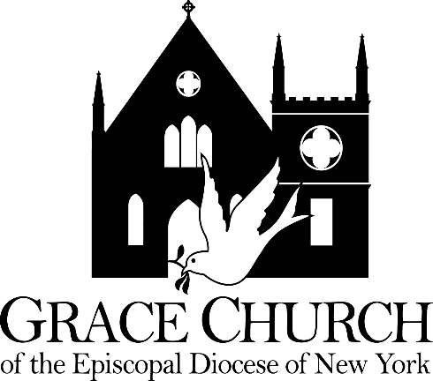
The Right Reverend Andrew ML. Dietsche, Bishop
The Right Reverend Allen Kunho Shin, Bishop Suffragan
The Right Reverend Mary Glasspool, Assistant Bishop
The Reverend Dr. Chip Graves, Rector
The Reverend Adolfo Moronta, Associate Priest
Peter Roberts, Director of Music of Grace Church
Juan Carlos Abreu, Director of Music of La Gracia
Linda Gallo, Youth Christian Education Coordinator
Suzan Ortega-Collado, Administrator
Taurino Juárez, Sexton

Third Sunday in Lent

March 7, 2021

33 Church Street
White Plains, New York 10601
www.gracewhiteplains.org
914-949-2874

VESTRY Linda Gallo, Senior Warden
Daisy Calderon, Junior Warden
Kevin Richards, Treasurer
Eileen McClean, Clerk
Class of 2021: Irene Alves, Eileen McClean, Mary Baker, Linda Gallo(Sr. Warden)
Class of 2022: Daniel Corsanego, Edythe Horne, Charlotte Roberson, Daisy Calderon(Jr. Warden)
Class of 2023: Lisa Daley, Andrea Hamilton-Singh, Kevin Richards, Sylvia Simon

Grace Church is a diverse congregation committed to a common life sustained by worship. We bear witness to God’s love in Christ through our life together and our service to the wider community. All are welcome.

The Third Sunday in Lent
March 7, 2021

Prelude Psalm 19 Marcello

Hymn: We the Lord’s people Abigail Fischer

We the Lord’s people,
heart and voice uniting,
praise him who called us
out of sin and darkness
into his own light,
that he might anoint us
a royal priesthood.

This is the Lord’s house,
home of all his people,
school for the faithful,
refuge for the sinner,
rest for the pilgrim,
haven for the weary;
all find a welcome.

This is the Lord’s day,
day of God’s own making,
day of creation,
day of resurrection,
day of the Spirit,
sign of heaven’s banquet,
day for rejoicing.

In the Lord’s service
bread and wine are offered,
that Christ may take them,
bless them, break and give them
to all his people,
his own life imparting,
food everlasting.
The Penitential Order BCP 351

Bless the Lord who forgives all our sins.
All: His mercy endures forever.

The Decalogue: Contemporary
Hear the commandments of God to his people:
I am the Lord your God who brought you out of bondage. You shall have no other gods but me.
Amen. Lord have mercy.

You shall not make for yourself any idol.
Amen. Lord have mercy.

You shall not invoke with malice the Name of the Lord your God.
Amen. Lord have mercy.

Remember the Sabbath Day and keep it holy.
Amen. Lord have mercy.

Honor your father and your mother.
Amen. Lord have mercy.

You shall not commit murder.
Amen. Lord have mercy.

You shall not commit adultery.
Amen. Lord have mercy.

You shall not steal.
Amen. Lord have mercy.

You shall not be a false witness.
Amen. Lord have mercy.

You shall not covet anything that belongs to your neighbor.
Amen. Lord have mercy.

Kyrie Eleison Missa de Sancta Maria Magdalena Healey Willan

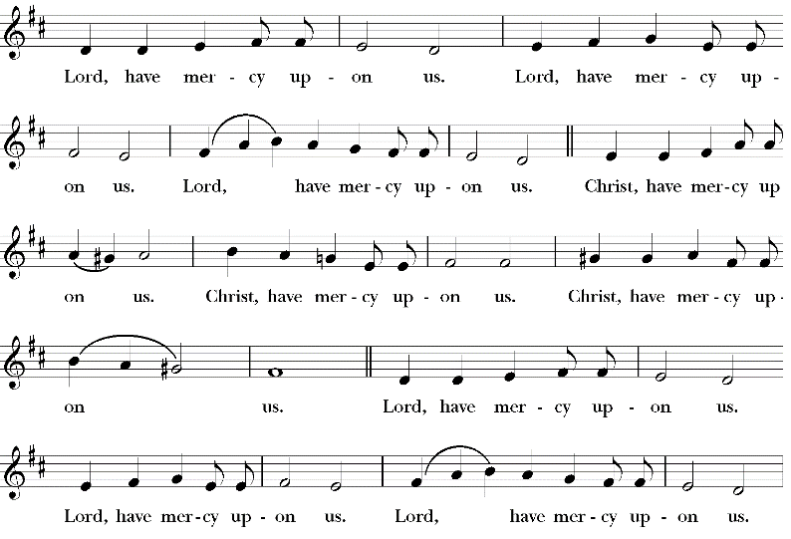

Hear what our Lord Jesus saith:
Thou shalt love the Lord thy God with all thy heart, and with
all thy soul, and with all thy mind. This is the first and great
commandment. And the second is like unto it: Thou shalt
love thy neighbor as thyself. On these two commandments
hang all the Law and the Prophets. Matthew 22:37-40

Priest: Let us confess our sins against God and our neighbor.

Most merciful God, we confess that we have sinned against you in thought, word, and deed,
by what we have done, and by what we have left undone. We have not loved you with our whole heart; we have not loved our neighbors as ourselves. We are truly sorry and we humbly repent. For the sake of your Son Jesus Christ, have mercy on us and forgive us; that we may delight in your will, and walk in your ways, to the glory of your Name. Amen.

Almighty God have mercy on you, forgive you all your sins through our Lord Jesus Christ, strengthen you in all goodness, and by the power of the Holy Spirit keep you in eternal life. Amen.

The Collect
Almighty God, you know that we have no power in ourselves to help ourselves: Keep us both outwardly in our bodies and inwardly in our souls, that we may be defended from all adversities which may happen to the body, and from all evil thoughts which may assault and hurt the soul; through Jesus Christ our Lord, who lives and reigns with you and the Holy Spirit, one God, for ever and ever. Amen.

The First Reading Exodus 20:1-17
Then God spoke all these words:
I am the Lord your God, who brought you out of the land of Egypt, out of the house of slavery; you shall have no other gods before me.
You shall not make for yourself an idol, whether in the form of anything that is in heaven above, or that is on the earth beneath, or that is in the water under the earth. You shall not bow down to them or worship them; for I the Lord your God am a jealous God, punishing children for the iniquity of parents, to the third and the fourth generation of those who reject me, but showing steadfast love to the thousandth generation of those who love me and keep my commandments.
You shall not make wrongful use of the name of the Lord your God, for the Lord will not acquit anyone who misuses his name.
Remember the sabbath day, and keep it holy. For six days you shall labour and do all your work. But the seventh day is a sabbath to the Lord your God; you shall not do any work—you, your son or your daughter, your male or female slave, your livestock, or the alien resident in your towns. For in six days the Lord made heaven and earth, the sea, and all that is in them, but rested the seventh day; therefore the Lord blessed the sabbath day and consecrated it.
Honor your father and your mother, so that your days may be long in the land that the Lord your God is giving you.
You shall not murder.
You shall not commit adultery.
You shall not steal.
You shall not bear false witness against your neighbor.
You shall not covet your neighbor’s house; you shall not covet your neighbor’s wife, or male or female slave, or ox, or donkey, or anything that belongs to your neighbor.
Reader: The Word of the Lord.
Thanks be to God

Psalm 19
Caeli enarrant
1 The heavens declare the glory of God, *and the firmament shows his handiwork.
2 One day tells its tale to another, *and one night imparts knowledge to another.
3 Although they have no words or language, *and their voices are not heard,
4 Their sound has gone out into all lands, *and their message to the ends of the world.
5 In the deep has he set a pavilion for the sun; *it comes forth like a bridegroom out of his
chamber; it rejoices like a champion to run its course.
6 It goes forth from the uttermost edge of the heavens and runs about to the end of it again;
*nothing is hidden from its burning heat.
7 The law of the Lord is perfect and revives the soul; *the testimony of the Lord is sure and gives wisdom to the innocent.
8 The statutes of the Lord are just and rejoice the heart; *the commandment of the Lord is
clear and gives light to the eyes.
9 The fear of the Lord is clean and endures for ever; *the judgments of the Lord are true
and righteous altogether.
10 More to be desired are they than gold, more than much fine gold, *sweeter far than honey,
than honey in the comb.
11 By them also is your servant enlightened, *and in keeping them there is great reward.
12 Who can tell how often he offends? *cleanse me from my secret faults.
13 Above all, keep your servant from presumptuous sins; let them not get dominion over me;
*then shall I be whole and sound, and innocent of a great offense.
14 Let the words of my mouth and the meditation of my heart be acceptable in your sight,
*O Lord, my strength and my redeemer.

The Epistle 1 Corinthians 1:18-25
The message about the cross is foolishness to those who are perishing, but to us who are being saved it is the power of God. For it is written,
“I will destroy the wisdom of the wise,
and the discernment of the discerning I will thwart.”
Where is the one who is wise? Where is the scribe? Where is the debater of this age? Has not God made foolish the wisdom of the world? For since, in the wisdom of God, the world did not know God through wisdom, God decided, through the foolishness of our proclamation, to save those who believe. For Jews demand signs and Greeks desire wisdom, but we proclaim Christ crucified, a stumbling block to Jews and foolishness to Gentiles, but to those who are the called, both Jews and Greeks, Christ the power of God and the wisdom of God. For God’s foolishness is wiser than human wisdom, and God’s weakness is stronger than human strength.
The Word of the Lord.
Thanks be to God

Silence is observed after the reading.

Holy Gospel of Our Lord Jesus Christ According to John 2:13-22
All: Glory to You Lord Christ.
The Passover of the Jews was near, and Jesus went up to Jerusalem. In the temple he found people selling cattle, sheep, and doves, and the money changers seated at their tables. Making a whip of cords, he drove all of them out of the temple, both the sheep and the cattle. He also poured out the coins of the money changers and overturned their tables. He told those who were selling the doves, “Take these things out of here! Stop making my Father’s house a marketplace!” His disciples remembered that it was written, “Zeal for your house will consume me.” The Jews then said to him, “What sign can you show us for doing this?” Jesus answered them, “Destroy this temple, and in three days I will raise it up.” The Jews then said, “This temple has been under construction for forty-six years, and will you raise it up in three days?” But he was speaking of the temple of his body. After he was raised from the dead, his disciples remembered that he had
The Gospel of the Lord.
Praise to You Lord Christ.

Sermon Fr. Adolfo Moronta

The Nicene Creed BCP 358
We believe in one God,
the Father, the Almighty,
maker of heaven and earth,
of all that is, seen and unseen.
We believe in one Lord,
Jesus Christ, the only Son of God,
eternally begotten of the Father,
God from God, Light from Light,
true God from true God,
begotten, not made,
of one Being with the Father.
Through him all things were made.
For us and for our salvation
he came down from heaven:

by the power of the Holy Spirit
he became incarnate from the Virgin Mary,
and was made man.
For our sake he was crucified under Pontius Pilate;
he suffered death and was buried.
On the third day he rose again
in accordance with the Scriptures;
he ascended into heaven
and is seated at the right hand of the Father.
He will come again in glory to judge the living and the dead,
and his kingdom will have no end.

We believe in the Holy Spirit, the Lord, the giver of life,
who proceeds from the Father and the Son.
With the Father and the Son he is worshiped and glorified.
He has spoken through the Prophets.
We believe in one holy catholic and apostolic Church.
We acknowledge one baptism for the forgiveness of sins.
We look for the resurrection of the dead,
and the life of the world to come. Amen

The Prayers of the People Form IV BCP 388
Let us pray for the church and the world.

Grant, Almighty God, that all who confess your Name may be united in your truth, live together in your love, and reveal your glory in the world.
Silence.
Lord, in your mercy
Hear our prayer.

Guide the people of this land, and of all the nations, in the ways of justice and peace; that we may honor one another and serve the common good.
Silence.
Lord, in your mercy
Hear our prayer.
Give us all a reverence for the earth as your own creation, that we may use its resources rightly in the service of others and to your honor and glory.
Silence.
Lord, in your mercy
Hear our prayer.

Bless all whose lives are closely linked with ours, and grant that we may serve Christ in them, and love one another as he loves us.
Silence.
Lord, in your mercy
Hear our prayer.
Comfort and heal all those who suffer in body, mind, or spirit; give them courage and hope in their troubles and bring them the joy of your salvation.
Silence.
Lord, in your mercy
Hear our prayer.
We commend to your mercy all who have died, that your will for them may be fulfilled; and we pray that we may share with all your saints in your eternal kingdom.
Silence.
Lord, in your mercy
Hear our prayer.

Almighty God, to whom our needs are known before we ask: Help us to ask only what accords with your will; and those good things which we dare not, or in our blindness cannot ask, grant us for the sake of your Son Jesus Christ our Lord. Amen.

The Peace
Offertory Hymn: Sing, my tongue, the glorious battle Agibail Fischer
1 Sing, my tongue, the glorious battle;
sing the ending of the fray.
Now above the cross, the trophy,
sound the loud triumphant lay:
tell how Christ, the world's Redeemer,
as a victim won the day.

2 Tell how, when at length the fullness
of th'appointed time was come,
He, the Word, was born of woman,
left for us His Father's home,
blazed the path of true obedience,
shone as light amidst the gloom.

3 Thus, with thirty years accomplished,
He went forth from Nazareth,
destined, dedicated, willing,
did His work, and met His death;
like a lamb He humbly yielded
on the cross His dying breath.

4 Faithful cross, true sign of triumph,
be for all the noblest tree;
none in foliage, none in blossom,
none in fruit your equal be;
symbol of the world's redemption,
for the weight that hung on thee!

5 Unto God be praise and glory:
to the Father and the Son,
to th'eternal Spirit honor
now and evermore be done;
praise and glory in the highest,
while the timeless ages run.

Announcements

THE HOLY COMMUNION

Eucharistic Prayer A BCP 361

Celebrant: The Lord be with you
People: And also with you.

Celebrant: Lift up your hearts.
People: We lift them up to the Lord.

Celebrant: Let us give thanks to the Lord our God.
People: It is right to give him thanks and praise.
Then, facing the Holy Table, the Celebrant proceeds
It is right, and a good and joyful thing, always and every-
where to give thanks to you, Father Almighty, Creator of
heaven and earth.
Through Jesus Christ our Lord; who was tempted in every way as we are, yet did not sin. By his grace we are able to triumph over every evil, and to live no longer for ourselves alone, but for him who died for us and rose again.
Therefore we praise you, joining our voices with Angels and
Archangels and with all the company of heaven, who for ever
sing this hymn to proclaim the glory of your Name:
Celebrant and People
Sanctus S114 Missa de Sancta Mari Magdalena Healey Willan
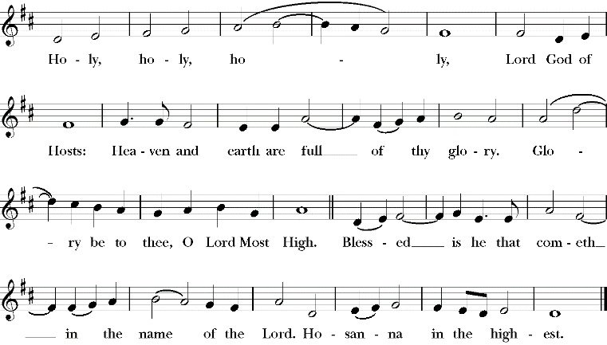
Holy, Holy, Holy Lord, God of power and might, heaven and earth are full of your glory. Hosanna in the highest. Blessed is he who comes in the name of the Lord. Hosanna in the highest.
The people stand or kneel.
Then the Celebrant continues
Holy and gracious Father: In your infinite love you made us
for yourself, and, when we had fallen into sin and become
subject to evil and death, you, in your mercy, sent Jesus
Christ, your only and eternal Son, to share our human
nature, to live and die as one of us, to reconcile us to you, the
God and Father of all.
He stretched out his arms upon the cross, and offered himself, in obedience to your will, a perfect sacrifice for the whole world.
At the following words concerning the bread, the Celebrant is to hold it,
or to lay a hand upon it; and at the words concerning the cup, to hold or
place a hand upon the cup and any other vessel containing wine to be
consecrated.
On the night he was handed over to suffering and death, our
Lord Jesus Christ took bread; and when he had given thanks
to you, he broke it, and gave it to his disciples, and said, "Take,
eat: This is my Body, which is given for you. Do this for the
remembrance of me."
After supper he took the cup of wine; and when he had given
thanks, he gave it to them, and said, "Drink this, all of you:
This is my Blood of the new Covenant, which is shed for you
and for many for the forgiveness of sins. Whenever you drink
it, do this for the remembrance of me."
Therefore we proclaim the mystery of faith:
Celebrant and People
Christ has died.
Christ is risen.
Christ will come again.
The Celebrant continues
We celebrate the memorial of our redemption, O Father, in
this sacrifice of praise and thanksgiving. Recalling his death,
resurrection, and ascension, we offer you these gifts.
Sanctify them by your Holy Spirit to be for your people the
Body and Blood of your Son, the holy food and drink of new
and unending life in him. Sanctify us also that we may faithfully
receive this holy Sacrament, and serve you in unity, constancy,
and peace; and at the last day bring us with all your saints
into the joy of your eternal kingdom.
All this we ask through your Son Jesus Christ: By him, and
with him, and in him, in the unity of the Holy Spirit all honor
and glory is yours, Almighty Father, now and for ever. AMEN.
And now, as our Savior  Christ has taught us,  we are bold to say, | As our Savior Christ  has taught us,  we now pray,

Our Father, who art in heaven,
hallowed be thy Name,
thy kingdom come,
thy will be done,
on earth as it is in heaven.
Give us this day our daily bread.
And forgive us our trespasses,
as we forgive those
who trespass against us.
And lead us not into temptation,
but deliver us from evil.
For thine is the kingdom,
and the power, and the glory,
for ever and ever. Amen.
The Breaking of the Bread
The Celebrant breaks the consecrated Bread.
A period of silence is kept.
Then may be sung or said
Christ our Passover is sacrificed for us;
Therefore let us keep the feast.
Facing the people, the Celebrant says the following Invitation

Agnus Dei Missa de Sancta Maria Magdalena Healey Willan
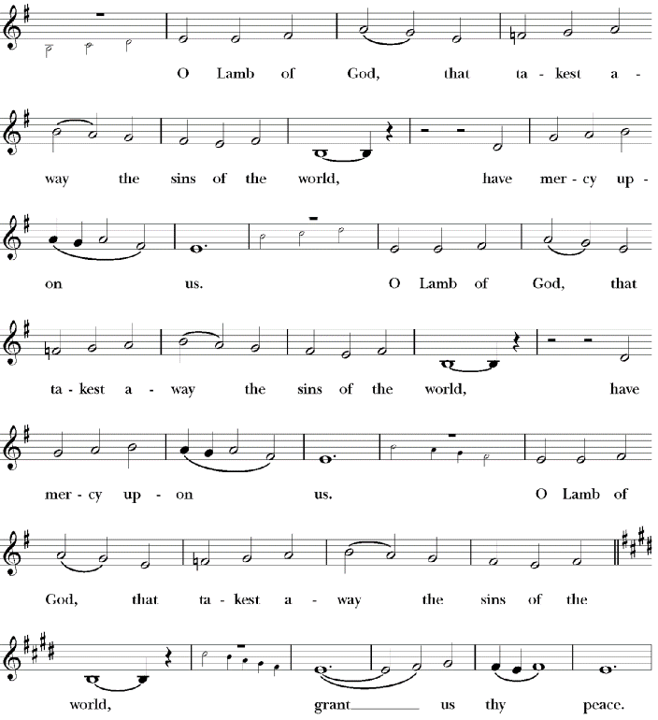
The Gifts of God for the People of God.
and may add | Take them in remembrance that Christ died for  you, and feed on him in your hearts by faith,  with thanksgiving.

Post Communion Prayer BCP 365

Let Us Pray

Eternal God, heavenly Father,
you have graciously accepted us as living members
of your Son our Savior Jesus Christ,
and you have fed us with spiritual food
in the Sacrament of his Body and Blood.

Send us now into the world in peace,
and grant us strength and courage
to love and serve you
with gladness and singleness of heart;
through Christ our Lord. Amen.

Blessing

May Christ, the Son of God, be manifest in you, that your lives may be a light to the world; and the blessing of God Almighty, the Father, the Son, and the Holy Spirit, be among you, and remain with you always. Amen.

Hymn: Here, O my Lord, I see thee face to face Abigail Fischer
1 Here, O my Lord, I see thee face to face;
here would I touch and handle things unseen,
here grasp with firmer hand th'eternal grace,
and all my weariness upon thee lean.

2 Here would I feed upon the bread of God,
here drink with thee the royal wine of heav'n;
here would I lay aside each earthly load,
here taste afresh the calm of sin forgiv'n.

3 This is the hour of banquet and of song;
this is the heav'nly table spread for me:
here let me feast, and, feasting, still prolong
the brief, bright hour of fellowship with thee.

4 I have no help but thine, nor do I need
another arm save thine to lean upon:
it is enough, my Lord, enough indeed;
my strength is in thy might, thy might alone.

5 Mine is the sin, but thine the righteousness;
mine is the guilt, but thine the cleansing blood;
here is my robe, my refuge, and my peace:
thy blood, thy righteousness, O Lord my God.

Dismissal

Postlude Prelude and fugue in E minor Bach
Celebrant & Preacher – The Rev. Adolfo Moronta, Associate Priest
Organist & Choir Director - Peter Roberts
Soloist –Abigail Fischer
If you are visiting with us for the first time, we welcome you to Grace Church!
Our liturgy is found in the Book of Common Prayer.
Our communion is open to all baptized Christians.
Please take the time to fill out one of our visitor cards which the ushers have available.
Your presence is a blessing to us; may our worship together be a blessing to you.
Grace Church Prayer List: We hold the following people in prayer: Lee Aldrich, Bernice Burton, Oscar Bunche, The Family of Charles & Barbara Wiggins, Cynthia Cole, Family of William J. Davis, Jean Beyer(Fr. Chip’s Father-In-Law), Kimberly Corelli, Darlene and Johnny Peoples, Inez Dale, Bill Dunphy, Cathy Dunphy, Cecile Fray, Corselli Family, Delaney Family, Sandra Esannason, Cindy Etheridge, Gregory Fucci, Laura Fields, Laurie Noone, Sid Fromm, Leigh Burton,
Lydia Green, Michael Nissman, Sylvia Howard, Linda Heusser, Jackie Jansky, Evgeniy Kaufman, Nellie King, Manoris Long, Donna Louis, Paxton Louis, Dorothy Lynch, Janice Moore, Kimmie Noone, Nicholas Furmoso (age 7), Selena Perry, Gladstone Reid, Leroy Reid, Uriel Reid, Al Sargent, Esteban Silvera, Sonia P. Smith, Norman Stanton, Susan Stanton, Dominick Vita, Natasha Vodyanitskaya, Ray Williams, Giovanna Romeo (Late Mother of Maria Romeo, Grace Church Bookkeeper)

Cedar Manor, Ossining: Robert Auld

Serving in the Armed Forces: Kenny Duffy, Denny J. Edmondson, Christopher P. Halstead, David Packer, Sgt. Christopher Vigliotti, Gunnery Sgt. Les Yearwood

Birthdays – March

2nd Joseph Brown
2nd Susan S. Stanton
2nd Cameron Owens
2nd Mayna D. Sanchez
6th George O’Hanlon
7th William Carter Davis
7th Emmi Grace Woodberry
12th Irene Alves
20th Elizabeth (Lee) Engel
21th Timothy Heavner
22nd Sharon Werth
22nd Niles Munsch
23rd Raymond Chang
24th Harrison G. Richards
26th Isabella J. Preston
28th Tiffany J. Reid

Weddings - March

3/2/1996
Thomas & Elizabeth Roach

3/9/1964
Gladstone & Elaine Reid

3/23/1969
Victor & Barbara Alleyne

3/24/1991
George O’Hanlon & Karen Southwick

Readers

8:00 AM - Brinda Bradley – 1st Reading & The Psalm, Stuart Madden 2nd Reading & The Prayers of the People

10:00 A.M. – Andrea Hamilton-Singh 1st Reading & the Psalm, Robert Soso 2nd Reading & the Prayer of the People

How to Pledge to Grace/La Gracia 2020-2021
The church is flexible in receiving your generosity during this challenging period of time. Blessings.

Option 1: The standard way of staying current with your pledge still applies.
Feel free to put a check in the mail and send it to the address below (Attention: Office Administrator). Bundling for a few weeks is fine.
13
Grace/La Gracia Episcopal Church
33 Church Street - 2nd Floor
White Plains NY 10601.

Option 2: There is a secure drop box on the red door at the front of Grace. The box will be checked regularly for financial contributions, including cash (which will be recorded). Kindly put your donation in an envelope with your contact info written clearly.

Option 3: Visit us on the web to donate electronically. www.gracewhiteplains.org
Look for the “Pledging” tab across the top and click on it. Then, you’ll see a yellow "Donate" button; clicking on that will take you to the site for electronic giving. You may use a credit card or with a PayPal account. For more details on PayPal, feel free to visit: (www.paypal.com).
If you’re interested in creating an account with PayPal, Michael Heffner is available to help explain or set up your account - michaelheffner08@gmail.com.
Please note – PayPal charges a fee to the church for these transactions (which is why a check in the drop box or sent by mail is preferable

Food Alliance
Give the Gift of Food

Good In Action
Please give the gift of food by donating to the Food Alliance God In Action Program. Please write Food Alliance in the memo portion of your check. To donate food please contact Fr. Adolfo at (646) 374-3414. Thank you!

Turn the page for Rite 13 Tear off.

Rite-13 Celebration 2021

Are you a “Grown-Up”?
In our society, the line between childhood and adulthood is often a fuzzy one. Unlike other cultures, we don’t have formalized rites of passage that define the points along the path to adulthood. We need ways to tell our young people they are making progress; they are growing and learning; they are becoming adults. The Journey to Adulthood program that we use attempts to do just that.

During the 10:00 AM Family Service on Sunday, March 21st, we will celebrate an important Rite of Passage with three of our teens. This liturgy is formally called “The Celebration of Adulthood”, but is more well-known as “Rite-13” since it takes place near the candidate’s 13th Birthday – much like a bar mitzvah or bat mitzvah.

During the ceremony, we recognize the gift of adulthood that God bestows on each one of us. This is a free gift that we cannot earn and need not prove. This gift is the essence of who we are. As we grow and mature in the journey to adulthood, our knowledge and skills increase, but the magical core of who we are remains the same.

These are the teenagers who we will celebrate and recognize on March 21st:

Eve Bradford
Rohan Kumar
Ivana Richards

Please keep them in your thoughts and prayers as they prepare. We invite you to be with us to witness this important event.

**************************************************************************************************************************************************************************************************************************************************************************
TEAR OFF

Grace Church’s Book of Wisdom for our Rite 13 Teens

In the spirit of such books as “Life’s Little Instruction Book”, we are compiling advice from people at Grace Church. Please use the space below to give a small bit of advice (one sentence or less) to our young teenagers who will be celebrating an important rite of passage (“Rite-13”) on Sunday, March 15th. Your advice can be something practical (like “Don’t go to bed with gum in your mouth.”) or something more profound (like “Be content to seem who you really are.”) Both are important to know!!

Please identify yourself by your first name and your age or stage in life. (For example, Bob – Age 41 or Susan – mother of toddler, Charles – grandfather, etc.)

Please put this completed form in the offering plate or email to George O’Hanlon at ohanlongeorge42@gmail.com, by Sunday, March 14th . Thanks for your help

