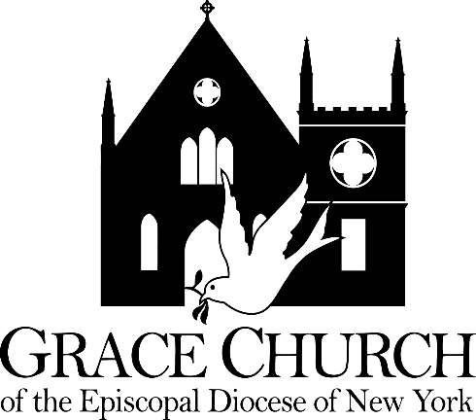

The Right Reverend Andrew ML. Dietsche, Bishop   
The Right Reverend Allen Kunho Shin, Bishop Suffragan   
The Right Reverend Mary Glasspool, Assistant Bishop   
The Reverend Dr. Chip Graves, Rector   
The Reverend Adolfo Moronta, Associate Priest   
Peter Roberts, Director of Music of Grace Church   
Juan Carlos Abreu, Director of Music of La Gracia   
Linda Gallo, Youth Christian Education Coordinator   
Suzan Ortega-Collado, Administrator   
Taurino Juárez, Sexton

**The Second Sunday of Easter**

**April 11, 2021**

**33 Church Street**

**White Plains, New York 10601**

[**www.gracewhiteplains.org**](http://www.gracewhiteplains.org)

**914-949-2874**

**VESTRY** Linda Gallo, Senior Warden   
Daisy Calderon, Junior Warden   
Kevin Richards, Treasurer

Eileen McClean, Clerk

**Class of 2021:** Irene Alves, Eileen McClean, Mary Baker, Sylvia Simon, Linda Gallo(Sr. Warden)

**Class of 2022:** Daniel Corsanego, Charlotte Roberson**,** Daisy Calderon(Jr. Warden)

**Class of 2023:** Lisa Daley, Andrea Hamilton-Singh, Kevin Richards

**Grace Church is a diverse congregation committed to a common life sustained by worship. We bear witness to God’s love in Christ through our life together and our service to the wider community. All are welcome.**

**Second Sunday of**

**Easter**

**April 11, 2021**

**8:00 AM** **Rite II** **BCP p. 355**

**10:00 AM Rite II** **BCP** **p. 355**

**HOLY EUCHARIST**

**Voluntary**  Adagio Charles Marie Widor

**Hymn #178 Alleluia, Alleluia, Give Thanks Abigail Fischer**

Chorus 1

Alleluia alleluia

Give thanks to the Risen Lord

Alleluia alleluia

Give praise to His Name

Verse 1

Jesus is Lord of all the earth

He is the King of creation

Verse 2

Spread the good news o'er all the earth

Jesus has died and has risen

Verse 3

We have been crucified with Christ

Now we shall live forever

Verse 4

Come let us praise the Living God

Joyfully sing to our Savior

The Easter Acclamation

Celebrant: Alleluia! Christ is risen!

**People: The Lord is risen indeed! Alleluia!**

**Collect for Purity**

**Gloria in Excelsis**  **William Mathias**  **Abigail Fischer**

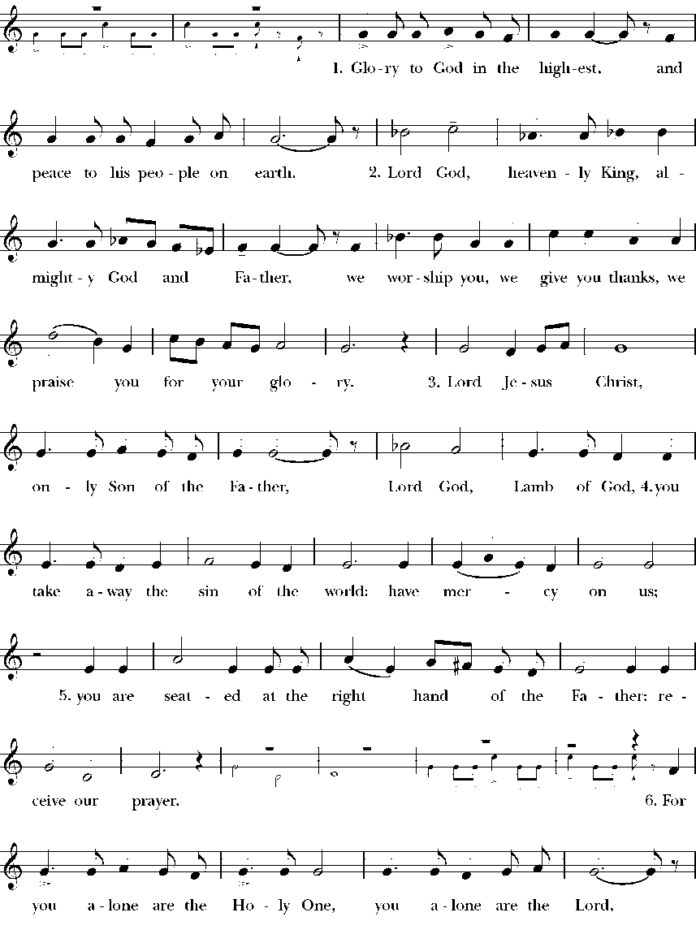

# **The Collect**

Almighty and everlasting God, who in the Paschal mystery established the new covenant of reconciliation: Grant that all who have been reborn into the fellowship of Christ's Body may show forth in their lives what they profess by their faith; through Jesus Christ our Lord, who lives and reigns with you and the Holy Spirit, one God, for ever and ever. Amen.

Reader: The Word of the Lord.

**All: Thanks be to God**

### The First Lesson Acts 4:32-35

Now the whole group of those who believed were of one heart and soul, and no one claimed private ownership of any possessions, but everything they owned was held in common. With great power the apostles gave their testimony to the resurrection of the Lord Jesus, and great grace was upon them all. There was not a needy person among them, for as many as owned lands or houses sold them and brought the proceeds of what was sold. They laid it at the apostles' feet, and it was distributed to each as any had need.

Reader: The word of the Lord.

**All: Thanks be to God.**

**Psalm 133**

Ecce, quam bonum!

1 Oh, how good and pleasant it is, **\*when brethren live together in unity!**

2 It is like fine oil upon the head **\*that runs down upon the beard,**

3 Upon the beard of Aaron, **\*and runs down upon the collar of his robe.**

4 It is like the dew of Hermon **\*that falls upon the hills of Zion.**

5 For there the Lord has ordained the blessing: **\*life for evermore.**

**The** **Epistle: 1 John 1:1-2:2**

We declare to you what was from the beginning, what we have heard, what we have seen with our eyes, what we have looked at and touched with our hands, concerning the word of life-- this life was revealed, and we have seen it and testify to it, and declare to you the eternal life that was with the Father and was revealed to us-- we declare to you what we have seen and heard so that you also may have fellowship with us; and truly our fellowship is with the Father and with his Son Jesus Christ. We are writing these things so that our joy may be complete.

This is the message we have heard from him and proclaim to you, that God is light and in him there is no darkness at all. If we say that we have fellowship with him while we are walking in darkness, we lie and do not do what is true; but if we walk in the light as he himself is in the light, we have fellowship with one another, and the blood of Jesus his Son cleanses us from all sin. If we say that we have no sin, we deceive ourselves, and the truth is not in us. If we confess our sins, he who is faithful and just will forgive us our sins and cleanse us from all unrighteousness. If we say that we have not sinned, we make him a liar, and his word is not in us.

My little children, I am writing these things to you so that you may not sin. But if anyone does sin, we have an advocate with the Father, Jesus Christ the righteous; and he is the atoning sacrifice for our sins, and not for ours only but also for the sins of the whole world.

Reader: The word of the Lord.

**All: Thanks be to God.**

**The Holy Gospel**

*The Holy Gospel of Our Lord Jesus Christ According to John*

**All: Glory to You Lord Christ.**

**John 20:19-31**

When it was evening on that day, the first day of the week, and the doors of the house where the disciples had met were locked for fear of the Jews, Jesus came and stood among them and said, "Peace be with you." After he said this, he showed them his hands and his side. Then the disciples rejoiced when they saw the Lord. Jesus said to them again, "Peace be with you. As the Father has sent me, so I send you." When he had said this, he breathed on them and said to them, "Receive the Holy Spirit. If you forgive the sins of any, they are forgiven them; if you retain the sins of any, they are retained."

But Thomas (who was called the Twin), one of the twelve, was not with them when Jesus came. So the other disciples told him, "We have seen the Lord." But he said to them, "Unless I see the mark of the nails in his hands, and put my finger in the mark of the nails and my hand in his side, I will not believe."

A week later his disciples were again in the house, and Thomas was with them. Although the doors were shut, Jesus came and stood among them and said, "Peace be with you." Then he said to Thomas, "Put your finger here and see my hands. Reach out your hand and put it in my side. Do not doubt but believe." Thomas answered him, "My Lord and my God!" Jesus said to him, "Have you believed because you have seen me? Blessed are those who have not seen and yet have come to believe."

Now Jesus did many other signs in the presence of his disciples, which are not written in this book. But these are written so that you may come to believe that Jesus is the Messiah, the Son of God, and that through believing you may have life in his name.

The Gospel of the Lord.

**All: Praise to You Lord Christ.**

# **The Sermon** **The Rev. Dr. Chip Graves**

# **The Nicene Creed BCP 358**

**We believe in one God,**

**the Father, the Almighty,**

**maker of heaven and earth,**

**of all that is, seen and unseen.**

**We believe in one Lord,**

**Jesus Christ, the only Son of God,**

**eternally begotten of the Father,**

**God from God, Light from Light,**

**true God from true God,**

**begotten, not made,**

**of one Being with the Father.**

**Through him all things were made.**

**For us and for our salvation**

**he came down from heaven:**

**by the power of the Holy Spirit**

**he became incarnate from the Virgin Mary,**

**and was made man.**

**For our sake he was crucified under Pontius Pilate;**

**he suffered death and was buried.**

**On the third day he rose again**

**in accordance with the Scriptures;**

**he ascended into heaven**

**and is seated at the right hand of the Father.**

**He will come again in glory to judge the living and the dead,**

**and his kingdom will have no end.**

**We believe in the Holy Spirit, the Lord, the giver of life,**

**who proceeds from the Father and the Son.**

**With the Father and the Son he is worshiped and glorified.**

**He has spoken through the Prophets.**

**We believe in one holy catholic and apostolic Church.**

**We acknowledge one baptism for the forgiveness of sins.**

**We look for the resurrection of the dead,**

**and the life of the world to come. Amen**

# **The Prayers of the People** **Form III** **BCP 387**

**The Leader and People pray responsively**

**Father, we pray for your holy Catholic Church;  
That we all may be one.**

**Grant that every member of the Church may truly and  
humbly serve you;  
That your Name may be glorified by all people.**

**We pray for all bishops, priests, and deacons;  
That they may be faithful ministers of your Word and  
Sacraments.**

**We pray for all who govern and hold authority in the nations  
of the world;  
That there may be justice and peace on the earth.**

**Give us grace to do your will in all that we undertake;  
That our works may find favor in your sight.**

**Have compassion on those who suffer from any grief or trouble;  
That they may be delivered from their distress.**

**Give to the departed eternal rest.  
Let light perpetual shine upon them.**

**We praise you for your saints who have entered into joy;  
May we also come to share in your heavenly kingdom.**

**Let us pray for our own needs and those of others.**

**The Peace**

**Offertory Anthem:** **I Know That my Redeemer Liveth Handel**

**THE HOLY COMMUNION**

**Eucharistic Prayer D Page 373 BCP**

*Celebrant:* ***The lord be with you***

**People*:* And also with you.**

*Celebrant:* ***Lift up your hearts.***

**People: We lift them up to the Lord.**

*Celebrant:* ***Let us give thanks to the Lord our God.***

**People:It is right to give him thanks and praise.**

*Then, facing the Holy Table, the Celebrant proceeds*

It is truly right to, Father, and to give you thanks;

for you alone are God, living and true, dwelling in light

inaccessible from before time and for ever.

Fountain of life and source of all goodness, you made all

things and fill them with your blessing; you created them to

rejoice in the splendor of your radiance.

Countless throngs of angels stand before you to serve you

night and day; and, beholding the glory of your presence,

they offer you unceasing praise. Joining with them, and

giving voice to every creature under heaven, we acclaim you,

and glorify your Name, as we sing (say),

*Celebrant and People*

Holy, Holy, Holy Lord, God of power and might,

heaven and earth are full of your glory.

Hosanna in the highest.

Blessed is he who comes in the name of the Lord.

Hosanna in the highest.

The people stand or kneel.

*Then the Celebrant continues*

We acclaim you, holy Lord, glorious in power. Your mighty

works reveal your wisdom and love. You formed us in your

own image, giving the whole world into our care, so that, in

obedience to you, our Creator, we might rule and serve all

your creatures. When our disobedience took us far from you,

you did not abandon us to the power of death. In your mercy

you came to our help, so that in seeking you we might find

you. Again and again you called us into covenant with you,

and through the prophets you taught us to hope for salvation.

Father, you loved the world so much that in the fullness of

time you sent your only Son to be our Savior. Incarnate by

the Holy Spirit, born of the Virgin Mary, he lived as one of

us, yet without sin. To the poor he proclaimed the good news

of salvation; to prisoners, freedom; to the sorrowful, joy. To

fulfill your purpose he gave himself up to death; and, rising

from the grave, destroyed death, and made the whole

creation new.

And, that we might live no longer for ourselves, but for him

who died and rose for us, he sent the Holy Spirit, his own

first gift for those who believe, to complete his work in

the world, and to bring to fulfillment the sanctification of all.

At the following words concerning the bread, the Celebrant is to hold it,

or lay a hand upon it, and at the words concerning the cup, to hold or

place a hand upon the cup and any other vessel containing wine to be

consecrated.

When the hour had come for him to be glorified by you, his

heavenly Father, having loved his own who were in the

world, he loved them to the end; at supper with them he took

bread, and when he had given thanks to you, he broke it, and

gave it to his disciples, and said, "Take, eat: This is my Body,

which is given for you. Do this for the remembrance of me."

After supper he took the cup of wine; and when he had given

thanks, he gave it to them, and said, "Drink this, all of you:

This is my Blood of the new Covenant, which is shed for you

and for many for the forgiveness of sins. Whenever you drink

it, do this for the remembrance of me."

Father, we now celebrate this memorial of our redemption.

Recalling Christ's death and his descent among the dead,

proclaiming his resurrection and ascension to your right

hand, awaiting his coming in glory; and offering to you, from

the gifts you have given us, this bread and this cup, we praise

you and we bless you.

*Celebrant and People*

We praise you, we bless you,

we give thanks to you,

and we pray to you, Lord our God.

*The Celebrant continues*

Lord, we pray that in your goodness and mercy your Holy

Spirit may descend upon us, and upon these gifts, sanctifying

them and showing them to be holy gifts for your holy people,

the bread of life and the cup of salvation, the Body and Blood

of your Son Jesus Christ.

Grant that all who share this bread and cup may become one

body and one spirit, a living sacrifice in Christ, to the praise

of your Name.

Remember, Lord, your one holy catholic and apostolic

Church, redeemed by the blood of your Christ. Reveal its

unity, guard its faith, and preserve it in peace.

Remember all who minister in your Church.

Remember all your people, and those who seek your truth.

Remember all who have died in the peace of Christ, and

those whose faith is known to you alone; bring them into

the place of eternal joy and light.

And grant that we may find our inheritance with [the Blessed

Virgin Mary, with patriarchs, prophets, apostles, and martyrs,]

all the saints who have found favor with you in ages past.

We praise you in union with them and give you glory through

your Son Jesus Christ our Lord.

Through Christ, and with Christ, and in Christ, all honor and

glory are yours, Almighty God and Father, in the unity of the

Holy Spirit, for ever and ever. AMEN.

And now, as our Savior

Christ has taught us,

we are bold to say,

has taught us,

we now pray,

**The Lord’s Prayer**

**Our Father, who art in heaven,**

**hallowed be thy Name,**

**thy kingdom come,**

**thy will be done,**

**on earth as it is in heaven.**

**Give us this day our daily bread.**

**And forgive us our trespasses,**

**as we forgive those**

**who trespass against us.**

**And lead us not into temptation,**

**but deliver us from evil.**

**For thine is the kingdom,**

**and the power, and the glory,**

**for ever and ever. Amen.**

**Sanctus and Beneditus Calvin Hampton Abigail Fischer**

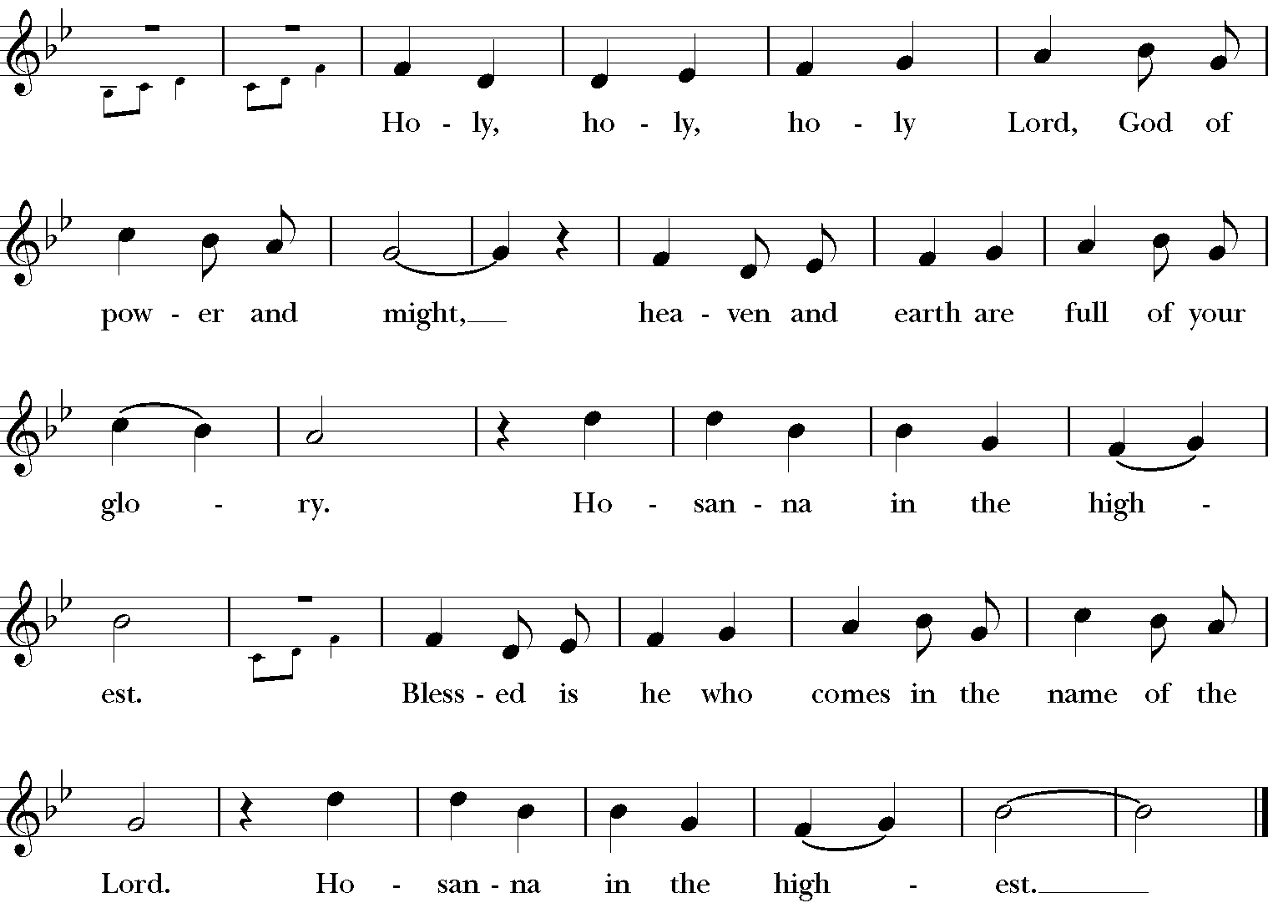

**At the Breaking of the Bread**

Alleluia, Christ our Passover is sacrificed for us.

**Therefore let us keep the feast, Alleluia.**

**Communion Hymn #188 Love’s redeeming work is done** **Abigail Fischer**

1 Love's redeeming work is done;

fought the fight, the battle won:

lo, our Sun's eclipse is o'er,

lo, he sets in blood no more.

2 Vain the stone, the watch, the seal;

Christ has burst the gates of hell;

death in vain forbids his rise;

Christ has opened paradise.

3 Lives again our glorious King;

where, O death, is now thy sting?

dying once, he all doth save;

where thy victory, O grave?

4 Soar we now where Christ has led,

following our exalted Head;

made like him, like him we rise;

ours the cross, the grave, the skies.

**The Post Communion Prayer BCP 365**

**Let Us Pray**

**Eternal God, heavenly Father,**

**you have graciously accepted us as living members**

**of your Son our Savior Jesus Christ,**

**and you have fed us with spiritual food**

**in the Sacrament of his Body and Blood.**

**Send us now into the world in peace,**

**and grant us strength and courage**

**to love and serve you**

**with gladness and singleness of heart;**

**through Christ our Lord. Amen.**

**Blessing**

May Christ, the Son of God, be manifest in you, that your lives may be a light to the world; and the blessing of God Almighty, the Father, the Son, and the Holy Spirit, be among you, and remain with you always**.** **Amen.**

**Hymn: # 209 We walk by faith and not by sight Abigail Fischer**

1 We walk by faith, and not by sight;

no gracious words we hear

from one who spoke as none e’er spoke,

but we believe him near.

2 We may not touch his hands and side,

nor follow where he trod,

yet in his promise we rejoice,

and cry, “My Lord and God!”

3 Help then, O Lord, our unbelief,

and may our faith abound

to call on you when you are near,

and seek where you are found:

4 that when our life of faith is done,

in realms of clearer light

we may behold you as you are

in full and endless sight.

5 We walk by faith, and not by sight;

no gracious words we hear

from one who spoke as none e’er spoke,

but we believe him near.

**Dismissal**



**Postlude Prelude and fugue in G major Bach**



Celebrant & Preacher – The Rev. Dr. Chip Graves, Rector  
 Organist & Choir Director - Peter Roberts

Soloist –Abigail Fischer

If you are visiting with us for the first time, we welcome you to Grace Church!

Our liturgy is found in the Book of Common Prayer.

Our communion is open to all baptized Christians.

Please take the time to fill out one of our visitor cards which the ushers have available.

Your presence is a blessing to us; may our worship together be a blessing to you.



Grace Church Prayer List: We hold the following people in prayer: Lee Aldrich, Bernice Burton, Oscar Bunche, The Family of Charles & Barbara Wiggins, Carole Carter, Cynthia Cole, Family of William J. Davis, Jean Beyer(Fr. Chip’s Father-In-Law), Kimberly Corelli, Darlene and Johnny Peoples, Inez Dale, Bill Dunphy, Cathy Dunphy, Cecile Fray, Corselli Family, Delaney Family, Sandra Esannason, Cindy Etheridge, Gregory Fucci, Laura Fields, Laurie Noone, Sid Fromm, Leigh Burton, Lydia Green, Michael Nissman, Sylvia Howard, Jackie Jansky, Evgeniy Kaufman, Nellie King, Manoris Long, Donna Louis, Paxton Louis, Dorothy Lynch, Janice Moore, Kimmie Noone, Nicholas Furmoso (age 7), Selena Perry, Gladstone Reid, Leroy Reid, Uriel Reid, Al Sargent, Esteban Silvera, Sonia P. Smith, Norman Stanton, Susan Stanton, Dominick Vita, Natasha Vodyanitskaya, Ray Williams, Giovanna Romeo (Late Mother of Maria Romeo, Grace Church Bookkeeper)

Cedar Manor, Ossining: Robert Auld

Serving in the Armed Forces: Kenny Duffy, Denny J. Edmondson, Christopher P. Halstead, David Packer, Sgt. Christopher Vigliotti, Gunnery Sgt. Les Yearwood

**Birthdays – April**

1st Eileen Victoria McClean

1st Shirley V. Spencer

3rd Karen Odom

5th Spencer J. Carden

5th Barbar Santos

6th Peter Munsch

7th Charlotte Roberson

12th Andrea Robinson

12th Linda Heusser

12th Huunjung(Hyun) Heffner

12th Eric Woodberry

12th Christopher M. Carson

12th Adi Kumar

14th Ava M. Maugham

16th Elsie G. Adams

17th Albert Sargent

20th Nathan (Nate) Hogan

22th Hailey C. Lynch

30th Rev. Norman D. Stanton

**Weddings - April**

**4/3**

Waymon & Charlotte Roberson

**4/11**

Everett Dickson & Karen Odom

**4/13**

Robert & Laura Auld

**4/20**

Joseph & Linda Gallo

**4/29**

Malik & Jean-Marie Bradford

**Readers**

**8:00 AM** - Brinda Bradley – 1st Reading & The Psalm, Stuart Madden 2nd Reading & The Prayers of the People

**10:00 A.M**. – Lisa Daley 1st Reading & the Psalm, Eileen McClean 2nd Reading & the Prayers of the People

**How to Pledge to Grace/La Gracia 2020-2021**

The church is flexible in receiving your generosity during this challenging period of time. Blessings.

**Option 1:** The standard way of staying current with your pledge still applies.

Feel free to put a check in the mail and send it to the address below (Attention: Office Administrator). Bundling for a few weeks is fine.

Grace/La Gracia Episcopal Church

33 Church Street - 2nd Floor

White Plains NY 10601.

**Option 2**: There is a secure drop box on the red door at the front of Grace. The box will be checked regularly for financial contributions, including cash (which will be recorded). Kindly put your donation in an envelope with your contact info written clearly.

**Option 3:** Visit us on the web to donate electronically. www.gracewhiteplains.org

Look for the “Pledging” tab across the top and click on it. Then, you’ll see a yellow "Donate" button; clicking on that will take you to the site for electronic giving. You may use a credit card or with a PayPal account. For more details on PayPal, feel free to visit:  (www.paypal.com).

If you’re interested in creating an account with PayPal, Michael Heffner is available to help explain or set up your account - [michaelheffner08@gmail.com.](michaelheffner08@gmail.com.%20%20)

Please note – PayPal charges a fee to the church for these transactions **(which is why a *check in the drop box or sent by mail is preferable.***

**Food Alliance**

**Give the Gift of Food**

**God In Action**

Please give the gift of food by donating to the Food Alliance God In Action Program. Please write Food Alliance in the memo portion of your check. To donate food please contact Fr. Adolfo at (646) 374-3414. Thank you



Today’s Music was offered in Celebration of

Salome Valter

13