The Right Reverend Andrew ML. Dietsche, Bishop
The Right Reverend Allen Kunho Shin, Bishop Suffragan
The Right Reverend Mary Glasspool, Assistant Bishop
The Reverend Dr. Chip Graves, Rector
The Reverend Adolfo Moronta, Associate Priest
Peter Roberts, Director of Music of Grace Church
Juan Carlos Abreu, Director of Music of La Gracia
Linda Gallo, Youth Christian Education Coordinator
Suzan Ortega-Collado, Administrator
Taurino Juárez, Sexton

The Sixth Sunday of Easter

May 9, 2021

33 Church Street
White Plains, New York 10601
www.gracewhiteplains.org
914-949-2874

VESTRY Linda Gallo, Senior Warden
Daisy Calderon, Junior Warden
Kevin Richards, Treasurer
Eileen McClean, Clerk
Class of 2021: Irene Alves, Eileen McClean, Mary Baker, Sylvia Simon, Linda Gallo(Sr. Warden)
Class of 2022: Daniel Corsanego, Charlotte Roberson, Daisy Calderon(Jr. Warden)
Class of 2023: Lisa Daley, Andrea Hamilton-Singh, Kevin Richards

Grace Church is a diverse congregation committed to a common life sustained by worship. We bear witness to God’s love in Christ through our life together and our service to the wider community. All are welcome.

Sixth Sunday of
Easter
May 9, 2021

HOLY EUCHARIST

Prelude: “Morning Song” Edward Elgar

Hymn # 292 O Jesu ,crowned with all renown Ross Keiser

1 O Throned, O Crowned with all renown,

Since Thou the earth hast trod,

Thou reignest, and by Thee come down

Henceforth the gifts of God:

By Thee the suns of space, that burn

Unspent their watches hold;

The hosts that turn, and still return,

Are swayed, and poised, and rolled.

2 And as, when ebbed the flood, our sires

Kneeled on the mountain sod,

While o'er the new world's altar fires,

Shone out the bow of God:

And sweetly fell the peaceful spell,

Word that shall aye avail,

"Summer and winter shall not cease,

Seed-time nor harvest fail,"—

3 Thus in their change, let frost and heat,

And winds and dews be given;

All fostering power, all influence sweet

Breathe from the bounteous heaven:

Attemper fair with gentle air

The sunshine and the rain,

That kindly earth with timely birth

May yield her fruits again;

4 That we may feed Thy poor aright,

And, gathering round Thy throne,

Here, in the holy angels' sight,

Repay Thee of Thine own:

That we may praise Thee all our days,

And with the Father's Name,

And with the Holy Spirit's gifts,

The Saviour's love proclaim.

The Easter Acclamation
Celebrant: Alleluia. Christ is risen.
People: The Lord is risen indeed. Alleluia.

Collect for Purity

Almighty God, to you all hearts are open, all desires known,
and from you no secrets are hid: Cleanse the thoughts of our
hearts by the inspiration of your Holy Spirit, that we may
perfectly love you, and worthily magnify your holy Name;
through Christ our Lord. Amen.

Gloria in Excelsis William Mathias Ross Keiser

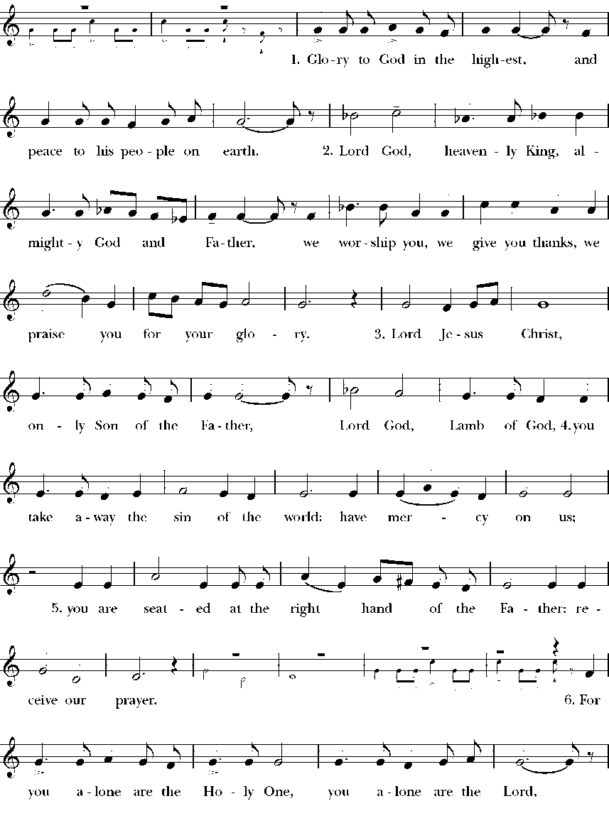

Glory to God in the highest,
and peace to his people on earth.
Lord God, heavenly King,
almighty God and Father,
we worship you, we give you thanks,
we praise you for your glory.
Lord Jesus Christ, only Son of the Father,
Lord God, Lamb of God,
you take away the sin of the world:
have mercy on us;
you are seated at the right hand of the Father:
receive our prayer.
For you alone are the Holy One,
you alone are the Lord,
you alone are the Most High,
Jesus Christ,
with the Holy Spirit,
in the glory of God the Father. Amen.

The Collect
O just and merciful God, you have provided for your people in times of famine as well as times of harvest. In your wisdom, you have called us to care for one another, loving our neighbors as ourselves. We ask that you strengthen our hearts to fulfill this call so that all your people may live with dignity. Grant us this through Jesus Christ our Lord. Amen.
Reader: The Word of the Lord.
All: Thanks be to God

The First Lesson Acts 10:44-48
While Peter was still speaking, the Holy Spirit fell upon all who heard the word. The circumcised believers who had come with Peter were astounded that the gift of the Holy Spirit had been poured out even on the Gentiles, for they heard them speaking in tongues and extolling God. Then Peter said, "Can anyone withhold the water for baptizing these people who have received the Holy Spirit just as we have?" So he ordered them to be baptized in the name of Jesus Christ. Then they invited him to stay for several days.
Reader: The word of the Lord.
All: Thanks be to God.

Psalm 98
Cantate Domino
1 Sing to the Lord a new song, *for he has done marvelous things.
2 With his right hand and his holy arm *has he won for himself the victory.
3 The Lord has made known his victory; *his righteousness has he openly shown in
the sight of the nations.
4 He remembers his mercy and faithfulness to the house of Israel, *and all the ends of
the earth have seen the victory of our God.
5 Shout with joy to the Lord, all you lands; *lift up your voice, rejoice, and sing.
6 Sing to the Lord with the harp, *with the harp and the voice of song.
7 With trumpets and the sound of the horn *shout with joy before the King,the Lord.
8 Let the sea make a noise and all that is in it, *the lands and those who dwell therein.
9 Let the rivers clap their hands, *and let the hills ring out with joy before the Lord,
when he comes to judge the earth.
10 In righteousness shall he judge the world *and the peoples with equity.

The Epistle: 1 John 5:1-6
Everyone who believes that Jesus is the Christ has been born of God, and everyone who loves the parent loves the child. By this we know that we love the children of God, when we love God and obey his commandments. For the love of God is this, that we obey his commandments. And his commandments are not burdensome, for whatever is born of God conquers the world. And this is the victory that conquers the world, our faith. Who is it that conquers the world but the one who believes that Jesus is the Son of God?
This is the one who came by water and blood, Jesus Christ, not with the water only but with the water and the blood. And the Spirit is the one that testifies, for the Spirit is the truth.
Reader: The word of the Lord.
All: Thanks be to God.

The Holy Gospel
The Holy Gospel of Our Lord Jesus Christ According to St. John
All: Glory to You Lord Christ.

John 15:9-17
Jesus said to his disciples, “As the Father has loved me, so I have loved you; abide in my love. If you keep my commandments, you will abide in my love, just as I have kept my Father’s commandments and abide in his love. I have said these things to you so that my joy may be in you, and that your joy may be complete.
“This is my commandment, that you love one another as I have loved you. No one has greater love than this, to lay down one’s life for one’s friends. You are my friends if you do what I command you. I do not call you servants any longer, because the servant does not know what the master is doing; but I have called you friends, because I have made known to you everything that I have heard from my Father. You did not choose me but I chose you. And I appointed you to go and bear fruit, fruit that will last, so that the Father will give you whatever you ask him in my name. I am giving you these commands so that you may love one another.”
The Gospel of the Lord
All: Praise to You Lord Christ.

The Sermon The Rev. Dr. Chip Graves

The Nicene Creed BCP 358

We believe in one God,
the Father, the Almighty,
maker of heaven and earth,
of all that is, seen and unseen.
We believe in one Lord,
Jesus Christ, the only Son of God,
eternally begotten of the Father,
God from God, Light from Light,
true God from true God,
begotten, not made,
of one Being with the Father.
Through him all things were made.
For us and for our salvation
he came down from heaven:

by the power of the Holy Spirit
he became incarnate from the Virgin Mary,
and was made man.
For our sake he was crucified under Pontius Pilate;
he suffered death and was buried.
On the third day he rose again
in accordance with the Scriptures;
he ascended into heaven
and is seated at the right hand of the Father.
He will come again in glory to judge the living and the dead,
and his kingdom will have no end.

We believe in the Holy Spirit, the Lord, the giver of life,
who proceeds from the Father and the Son.
With the Father and the Son he is worshiped and glorified.
He has spoken through the Prophets.
We believe in one holy catholic and apostolic Church.
We acknowledge one baptism for the forgiveness of sins.
We look for the resurrection of the dead,
and the life of the world to come. Amen

The Prayers of the People Form III BCP 387
The Leader and People pray responsively
Father, we pray for your holy Catholic Church;
That we all may be one.
Grant that every member of the Church may truly and
humbly serve you;
That your Name may be glorified by all people.
We pray for all bishops, priests, and deacons;
That they may be faithful ministers of your Word and
Sacraments.
We pray for all who govern and hold authority in the nations
of the world;
That there may be justice and peace on the earth.
Give us grace to do your will in all that we undertake;
That our works may find favor in your sight.
Have compassion on those who suffer from any grief or trouble;
That they may be delivered from their distress.
Give to the departed eternal rest.
Let light perpetual shine upon them.
We praise you for your saints who have entered into joy;
May we also come to share in your heavenly kingdom.
Let us pray for our own needs and those of others.
On this Mother’s Day, we give thanks to God for the divine gift of motherhood in all its diverse forms. Let us pray for all the mothers among us today; for our own mothers, those living and those who have passed away; for the mothers who loved us and for those who fell short of loving us fully; for all who hope to be mothers some day and for those whose hope to have children has been frustrated; for all mothers who have lost children; for all women and men who have mothered others in any way—those who have been our substitute mothers and we who have done so for those in need; for the earth that bore us and provides our sustenance. We pray this all in the name of God.

Amen

The Peace

Offertory Anthem # 411 Earth and all stars, loud rushing planets Ross Keiser
Earth and all stars, Loud rushing planets
Sing to the Lord a new song!
Hail, wind, and rain, Loud blowing snowstorm
Sing to the Lord a new song!
God has done marvelous things.
I too sing praises with a new song!
Trumpet and pipes! Loud clashing cymbals!
Sing to the Lord a new song!
Harp, lute, and lyre! Loud humming cellows!
Sing to the Lord a new song!
Engines and steel! Loud pounding hammers
Sing to the Lord a new song!
Limestone and beams, Loud building workers
Sing to the Lord a new song!
Classrooms and labs, Loud boiling test tubes
Sing to the Lord a new song!
Athlete and band, Loud cheering people
Sing to the Lord a new song!
Knowledge and truth, Loud sounding wisdom
Sing to the Lord a new song!
Daughter and son, Loud praying members
Sing to the Lord a new song!
THE HOLY COMMUNION

Eucharistic Prayer D BCP 373

Celebrant: The lord be with you
People: And also with you.

Celebrant: Lift up your hearts.
People: We lift them up to the Lord.

Celebrant: Let us give thanks to the Lord our God.
People: It is right to give him thanks and praise.

Then, facing the Holy Table, the Celebrant proceeds
It is truly right to glorify you, Father, and to give you thanks;
for you alone are God, living and true, dwelling in light
inaccessible from before time and for ever.

Fountain of life and source of all goodness, you made all
things and fill them with your blessing; you created them to
rejoice in the splendor of your radiance.

Countless throngs of angels stand before you to serve you
night and day; and, beholding the glory of your presence,
they offer you unceasing praise. Joining with them, and
giving voice to every creature under heaven, we acclaim you,
and glorify your Name, as we sing (say),

Celebrant and People

Sanctus and Beneditus Calvin Hampton Ross Keiser

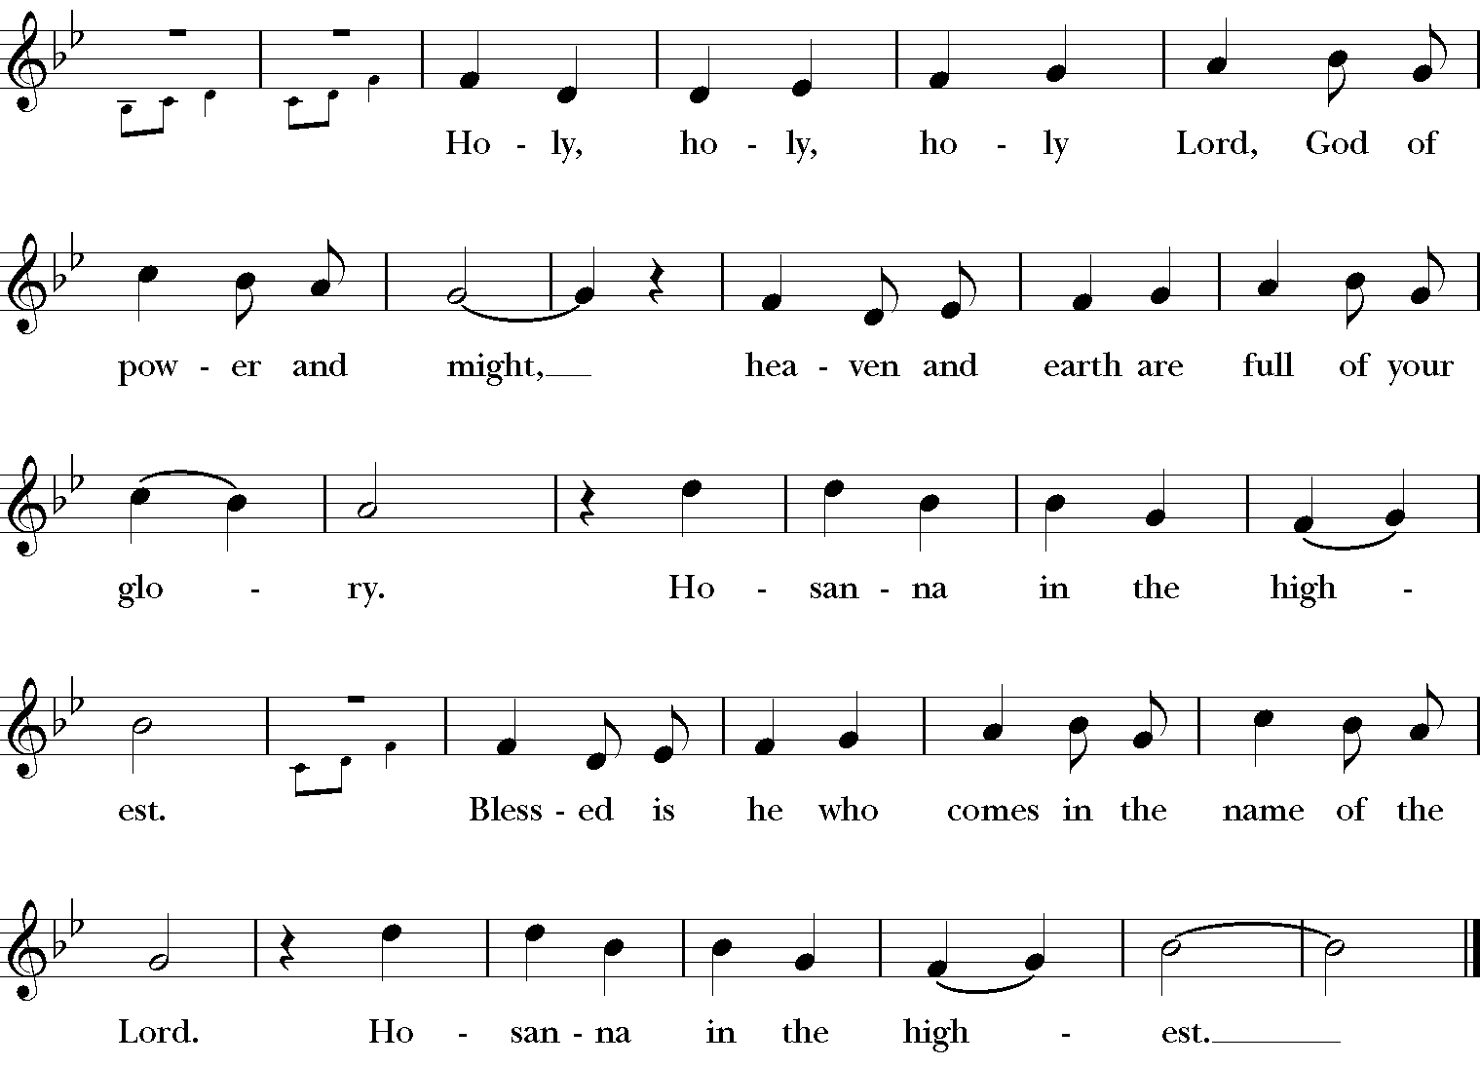

Holy, Holy, Holy Lord, God of power and might, heaven and earth are full of your glory.
Hosanna in the highest. Blessed is he who comes in the name of the Lord. Hosanna in the highest.

The people stand or kneel.

Then the Celebrant continues

We acclaim you, holy Lord, glorious in power. Your mighty
works reveal your wisdom and love. You formed us in your
own image, giving the whole world into our care, so that, in
obedience to you, our Creator, we might rule and serve all
your creatures. When our disobedience took us far from you,
you did not abandon us to the power of death. In your mercy
you came to our help, so that in seeking you we might find
you. Again and again you called us into covenant with you,
and through the prophets you taught us to hope for salvation.

Father, you loved the world so much that in the fullness of
time you sent your only Son to be our Savior. Incarnate by
the Holy Spirit, born of the Virgin Mary, he lived as one of
us, yet without sin. To the poor he proclaimed the good news
of salvation; to prisoners, freedom; to the sorrowful, joy. To
fulfill your purpose he gave himself up to death; and, rising
from the grave, destroyed death, and made the whole
creation new.

And, that we might live no longer for ourselves, but for him
who died and rose for us, he sent the Holy Spirit, his own
first gift for those who believe, to complete his work in
the world, and to bring to fulfillment the sanctification of all.

When the hour had come for him to be glorified by you, his
heavenly Father, having loved his own who were in the
world, he loved them to the end; at supper with them he took
bread, and when he had given thanks to you, he broke it, and
gave it to his disciples, and said, "Take, eat: This is my Body,
which is given for you. Do this for the remembrance of me."

After supper he took the cup of wine; and when he had given
thanks, he gave it to them, and said, "Drink this, all of you:
This is my Blood of the new Covenant, which is shed for you
and for many for the forgiveness of sins. Whenever you drink
it, do this for the remembrance of me."

Father, we now celebrate this memorial of our redemption.
Recalling Christ's death and his descent among the dead,
proclaiming his resurrection and ascension to your right
hand, awaiting his coming in glory; and offering to you, from
the gifts you have given us, this bread and this cup, we praise
you and we bless you.

Celebrant and People

We praise you, we bless you,
we give thanks to you,
and we pray to you, Lord our God.

The Celebrant continues

Lord, we pray that in your goodness and mercy your Holy
Spirit may descend upon us, and upon these gifts, sanctifying
them and showing them to be holy gifts for your holy people,
the bread of life and the cup of salvation, the Body and Blood
of your Son Jesus Christ.

Grant that all who share this bread and cup may become one
body and one spirit, a living sacrifice in Christ, to the praise
of your Name.

Remember, Lord, your one holy catholic and apostolic
Church, redeemed by the blood of your Christ. Reveal its
unity, guard its faith, and preserve it in peace.

Remember all who minister in your Church.
Remember all your people, and those who seek your truth.
Remember all who have died in the peace of Christ, and
those whose faith is known to you alone; bring them into
the place of eternal joy and light.

And grant that we may find our inheritance with [the Blessed
Virgin Mary, with patriarchs, prophets, apostles, and martyrs,]
all the saints who have found favor with you in ages past.
We praise you in union with them and give you glory through
your Son Jesus Christ our Lord.

Through Christ, and with Christ, and in Christ, all honor and
glory are yours, Almighty God and Father, in the unity of the
Holy Spirit, for ever and ever. AMEN.

And now, as our Savior
Christ has taught us,
we are bold to say,

The Lord’s Prayer

Our Father, who art in heaven,
hallowed be thy Name,
thy kingdom come,
thy will be done,
on earth as it is in heaven.
Give us this day our daily bread.
And forgive us our trespasses,
as we forgive those
who trespass against us.
And lead us not into temptation,
but deliver us from evil.
For thine is the kingdom,
and the power, and the glory,
for ever and ever. Amen.

At the Breaking of the Bread

Alleluia, Christ our Passover is sacrificed for us.
Therefore let us keep the feast, Alleluia.

The Gifts of God for the People of God.

Communion Hymn #705 As Saints of old their first fruits brought Ross Keiser
As saints of old their first-fruits brought
of vineyard, flock, and field
to God, the giver of all good,
the source of bounteous yield;
so we today our first fruits bring:
the wealth of this good land,
of farm and market, shop and home,
of mind and heart and hand.

A world in need now summons us
to labor, love, and give,
to make our life an offering
to God, that all may live.
The church of Christ is calling us
to make the dream come true:
a world redeemed, by Christ-like love,
all life in Christ made new.

With gratitude and humble trust
we bring our best to you,
not just to serve your cause, but share
your love with neighbors too.
O God, who gave yourself to us
in Jesus Christ your Son,
help us to give ourselves each day
until life's work is done.

The Post Communion Prayer BCP 365

Let Us Pray

Eternal God, heavenly Father,
you have graciously accepted us as living members
of your Son our Savior Jesus Christ,
and you have fed us with spiritual food
in the Sacrament of his Body and Blood.

Send us now into the world in peace,
and grant us strength and courage
to love and serve you
with gladness and singleness of heart;
through Christ our Lord. Amen.

Blessing

May Christ, the Son of God, be manifest in you, that your lives may be a light to the world; and the blessing of God Almighty, the Father, the Son, and the Holy Spirit, be among you, and remain with you always. Amen.

Hymn # 400 All creatures of our God and King Ross Keiser

1 *All creatures worship God most high,
lift up your voice in earth and sky,
alleluia, alleluia!
Thou burning sun with golden beam,
thou silver moon with softer gleam,
O sing ye, O sing ye, alleluia, alleluia, alleluia!

2 Thou rushing wind that art so strong,
ye clouds that sail in heav’n along,
alleluia, alleluia!
Thou rising morn in praise rejoice,
ye lights of evening, find a voice,
O sing ye, O sing ye, alleluia, alleluia, alleluia!

3 Thou flowing water, pure and clear,
make music for thy God to hear,
alleluia, alleluia!
Thou fire so masterful and bright,
that givest all both warmth and light,
O sing ye, O sing ye, alleluia, alleluia, alleluia!

4 Dear mother earth, who day by day,
unfoldest blessings on our way,
alleluia, alleluia!
The flow’rs and fruits that in thee grow,
let them God’s glory also show,
O sing ye, O sing ye, alleluia, alleluia, alleluia!

Dismissal

Postlude Choral - Minuet Leon Boellmann

Celebrant & Preacher – The Rev. Dr. Chip Graves, Rector
Organist & Choir Director - Peter Roberts
Soloist – Ross Keiser
If you are visiting with us for the first time, we welcome you to Grace Church!
Our liturgy is found in the Book of Common Prayer.
Our communion is open to all baptized Christians.
Please take the time to fill out one of our visitor cards which the ushers have available.
Your presence is a blessing to us; may our worship together be a blessing to you.
Grace Church Prayer List: We hold the following people in prayer: Lee Aldrich, Bernice Burton, Oscar Bunche, The Family of Charles & Barbara Wiggins, Carole Carter, Cynthia Cole, Caroline Bordes, Family of William J. Davis, Jean Beyer(Fr. Chip’s Father-In-Law), Kimberly Corelli, The Family of Darlen & Johnny Peoples, Inez Dale, Bill Dunphy, Cathy Dunphy, Cecile Fray, Corselli Family, Delaney Family, Sandra Esannason, Cindy Etheridge, Laura Fields, Laurie Noone, Sid Fromm, Leigh Burton, Lydia Green, Michael Nissman, Sylvia Howard, Jackie Jansky, Evgeniy Kaufman, Nellie King, Manoris Long, Donna Louis, Paxton Louis, Dorothy Lynch, Janice Moore, Kimmie Noone, Nicholas Furmoso (age 7), Selena Perry, Gladstone Reid, Leroy Reid, Uriel Reid, Al Sargent, Esteban Silvera, Sonia P. Smith, Norman Stanton, Susan Stanton, Dominick Vita, Natasha Vodyanitskaya, Ray Williams, Giovanna Romeo (Late Mother of Maria Romeo, Grace Church Bookkeeper), and the Country of India.

Cedar Manor, Ossining: Robert Auld
Serving in the Armed Forces: Kenny Duffy, Denny J. Edmondson, Christopher P. Halstead, David Packer, Sgt. Christopher Vigliotti, Gunnery Sgt. Les Yearwood

Birthdays – May
1st Robert Auld
3rd Keith D. Graves
4th Arlene Robert Grant
5th Viktoria O'Hanlon
6th Norene Bueti
6th Dr. Barbra McCune
7th Brianna Parkinson
11th Helena Aldrich
13th Zoey Brown
13th Patricia Hosten
14th Sharon Revan-Salmon
14th Brian Owens
14th Owen Larson
16th Nellie A. King
16th Oscar Bunche
17th Kayla Marie Graves
19th Robert W. Allen
21th Carole Lashley
22th Carolyn Rogers
24th Kendal Mangum
25th Shane Daughtry
26th Tahra Grant
27th James Brown
29th Audrey A. Taylor
30th Hillary Fleming

Weddings - May

5/1
Lloyd & Janine Daughtry

5/5
Ronak & Augustina Kumar

5/9
Paxton & Donna Louis
5/27
Melanie Jackson & Marc Walters

5/31
Valentine Parkinson & Margaret Broomfield

Readers

8:00 AM - Brinda Bradley – 1st Reading & The Psalm, Stuart Madden 2nd Reading & The Prayers of the People

10:00 A.M. – Lauren Reid - 1st Reading, Uriel Reid -The Psalm & the 2nd Reading, Matthew Reid – The Prayers of the People

Acolytes – 10:00 AM Service

Anna, Nikolas, and Vika O’Hanlon, and Lauren Reid

How to Pledge to Grace/La Gracia 2020-2021

The church is flexible in receiving your generosity during this challenging period of time. Blessings.

Option 1: The standard way of staying current with your pledge still applies.
Feel free to put a check in the mail and send it to the address below (Attention: Office Administrator). Bundling for a few weeks is fine.

Grace/La Gracia Episcopal Church
33 Church Street - 2nd Floor
White Plains NY 10601.

Option 2: There is a secure drop box on the red door at the front of Grace. The box will be checked regularly for financial contributions, including cash (which will be recorded). Kindly put your donation in an envelope with your contact info written clearly.

Option 3: Visit us on the web to donate electronically. www.gracewhiteplains.org
Look for the “Pledging” tab across the top and click on it. Then, you’ll see a yellow "Donate" button; clicking on that will take you to the site for electronic giving. You may use a credit card or with a PayPal account. For more details on PayPal, feel free to visit: (www.paypal.com).
If you’re interested in creating an account with PayPal, Michael Heffner is available to help explain or set up your account - michaelheffner08@gmail.com.

Please note – PayPal charges a fee to the church for these transactions (which is why a check in the drop box or sent by mail is preferable.

Episcopal Charities Sunday
Sharing our Abundance

Last May, 10% of New Yorkers reported not having enough food to eat. In December, that number jumped to 14%. That means 2,723,000 of our neighbors lack the ability to provide for their basic needs. On May 9th, please join us in celebrating Episcopal Charities Sunday in support of the life-saving work of the 62 feeding programs Episcopal Charities funds. 100% of your donation will go directly to these crucial food pantries, soup kitchens, and brown-bag programs. To donate, visit ec-ny.org/ecsunday or text SUNDAY to 91999.

Food Alliance
Give the Gift of Food

God In Action

Please give the gift of food by
donating to the Food Alliance God In Action Program. Please write Food Alliance in the memo portion of your check. To donate food please contact Fr. Adolfo at (646) 374-3414. Thank you

The Summer Angelus 2021

The Summer Angelus can be expected at the beginning of June. Share with all of us your plans for this Covid summer! Send time through May 16th to: marygene57@msn.com

Graduate Recognition is Sunday, June 13th

Our Grace/ La Gracia Family is looking forward once again to honoring our graduates and all of their achievements! Please contact Lauren Reid at Lrrmink@gmail.com or (914)-924-8230 by May 31st. If you know of a member of Grace/LaGracia who is graduating from high school, college, Graduate school, or with a Post Master’s degree. In addition, if you belong to a church committee that wishes to contribute to those being honored, please contact Lauren by May 31st as well.
15

Today’s Music was offered in Celebration of:
Otis Benjamin Glover
Eric Ross Woodberry
Aaron Ross Woodberry
Emmi Grace Woodberry

16

