WINTER 2023

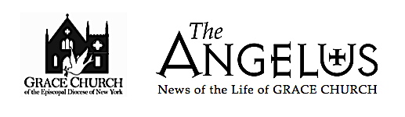
Over 150 Years in the Heart of White Plains

Dear Grace Church Family,

Winter is here! A period of change when the weather gets colder and where many changes occur in our plants, as the deciduous trees grow barren. Everyone feels some magic in the air, because of frosts, crystal nights, snow and an amazing atmosphere. Days become short, as usual not so sunny, and nights are becoming longer. The winter season is simply a special time of the year.

Just as we have different seasons throughout the year, the church Liturgical Calendar goes through its own transitions. Our Church year begins with Advent, a time of holy waiting of keeping vigil for the birth of Christ. Advent then takes us to the Christmas season which lasts twelve days, from Christmas Day until Jan. 5, the day before the Epiphany. Epiphany is the manifestation of Christ to the peoples of the earth. From Epiphany we go to Lent, a season of prayer, penitence and fasting in preparation for the Paschal feast. Then we have the Easter season or the feast of Christ’s resurrection. The liturgical year closes with the season after Pentecost, which begins on the Monday following Pentecost, and continues through most of the summer and autumn.

2023 will be an exciting year for Grace Church. The following are some of the activities that, God willing, we will have. We will begin the year with the toy distribution for both Grace and La Gracia on January 8. That will be followed by our Annual Meeting and the election of new Vestry members towards the end of the month. February will follow with Black History Month. March 8th is International Women’s day. May leads us into Mother’s Day (May 14th) and to the consecration of the new Bishop, The Rev. Matthew Foster Heyd, on May 20th. On June 18th we will have the celebration of Father’s day; and during the summer months some of the programmed activities are our Church Barbecue at the Rectory and our second Life in the Spirit Seminar. In November, the Church will hold our Thanksgiving Dinner and our Annual Christmas Dinner in December. All major activities will be done in combination with La Gracia.

Grace Church, God has a plan for this church. He has a vision for Grace / La Gracia, and He is slowly unveiling his project to us. I am sure that His project includes growth, renewal, and change which have all begun. But His plan will not unveil by itself, since it requires our active participation with our skills, our time and, even sometimes, our sacrifices.
Rev. Adolfo Moronta+

CALENDAR OF EVENTS

JANUARY, FEBRUARY, MARCH 2023

JANUARY
- January 1 New Years Day
- January 6 Epiphany
- January 8 Epiphany Service and Toy Drive Distribution for Children and Youth.
- January 15 MLK Sunday and Sermon
- January 15 Senor de Esquipulas de Guatemala (La Gracia)
- January 16 MLK Day
- January 22 Virgin of Altagracia (La Gracia)
- January 29-February 5 Priest In Charge Vacation
- Every Wednesday DTM Concerts at 11:30 PM till May 2023

FEBRUARY
- Black History Month
- February 12 Valentine’s Day Celebration (Grace/ La Gracia)
- February 14 Valentine’s Day
- February 20 Presidents Day
- February 22 Ash Wednesday
Ash Wednesday Services
7:30 AM & 12:00 PM Grace Service
7:30 PM Bilingual Service
- February 26 La Gracia Committee Meeting
- February 28 Vestry Meeting
- Every Friday of Lent Stations of the cross

MARCH
- Women’s History Month
- Lent Season continues
- March 1 Parroquial Report Due
- March 8 International Women’s Day
- March 26 La Gracia Committee Meeting
- March 28 Vestry Meetin

The Rev. Matthew Foster Heyd, Bishop Elect

of the Episcopal Diocese of New York
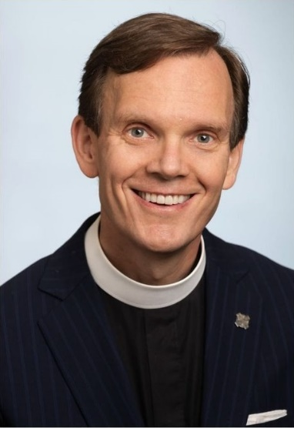

On December 3 the Diocese of New York held a special convention to elect our next Diocesan Bishop. The Convention had the participation of our Bishops, the Clergy of the Diocese and the Lay Delegates from all the congregations. In this event The Rev. Matthew Foster Heyd was elected Bishop Coadjutor. A Bishop Coadjutor is an Assistant Bishop with the right of succession upon the resignation of the Diocesan Bishop. This means that when Bishop Dietsche retires in 2024 The Rev. Matthew Foster Heyd will become our Diocesan Bishop.

The Rev. Matthew Foster Heyd grew up in North Carolina but was raised up for ministry in the Diocese of New York. He has spent his entire adult life working for the renewl of the Episcopal Church at the congregational, diocesan, and national levels. He will be consecrated Bishop on May 20.
Bishop Dietsche will continue to serve as Bishop Diocesan through April 2024. He remains responsible for the leadership and activities of the Diocese of New York. After his consecration in May, the Bishop Coadjutor will initially join the regular schedule of parish visitations and have jurisdiction over the ordination process.

The Bishop –Elect, Matthew Heyd recently shared with the Diocese: “My focus with our Diocese in transition will be listening, learning, and preparing so that we can strengthen our systems for ministry — our shared pastoral fabric — together.”

REFLECTIONS FROM A VOTING DELEGATE
By Irene Alves

In the early morning of Saturday, December 3, 2022 I traveled with Sandy McAllister to the Cathedral Church of Saint John the Divine in New York City. Driving through the rain we commented about the importance of our mission: Sandy to observe and I to vote for the next Bishop Coadjutor-Elect of the Episcopal Diocese of New York. We had to leave so early because all voting delegates had to meet the 9:00 am voting check-in deadline. Other criteria that had to be met was taking a Covid-19 rapid test within 24 hours of arriving and bringing a photo of the result to the Cathedral, bringing your smartphone for voting, and being physically present to vote. Daisy Calderon and Fr. Moronta were also voting delegates from Grace. This election was of such importance because whomever was elected he/she would become the next Bishop of the Diocese of New York and set its future direction.
At 9:00am the Holy Eucharist (Feast of Francis Xavier) began with The Right Reverend Andrew ML. Dietsche, Celebrant & Preacher (XVI Bishop of New York), assisted by The Right Reverend Allen K Shin ( Bishop Suffragan of New York) , The Right Reverend Mary D. Glasspool ( Bishop Assistant of New York), The Reverend Canon John D. Perris (Canon to the Ordinary, Chaplain to Bishop Dietsche), The Reverend Masud Ibn Syedullah TSSF, Convention Chaplain, Greg Purnhagen, Soloist, and Daniel Ficarri, Organist. The Deacons were: The Reverend Deacon Jean Marie Angelo, Saint John’s Church, Wilmer and Trinity Saint Paul’s Church, New Rochelle and The Reverend Deacon Pedro Rodriguez, Jr., SouthBronxMinistryTeam.
Voting began immediately after the Eucharist, following instructions and trials. The first ballot included all of the candidates. They were: The Reverend Matthew Foster Heyd, The Reverend Stephanie M.Johnson, The Reverend Matthew Hoxsie Mead, The Reverend Steven D. Paulikas and The Reverend Robert Jermonde Taylor. After the first ballot, Rev. Stephanie Johnson withdrew her name from consideration and the second ballot began. After the second ballot, Rev. Matthew Mead withdrew his name from consideration and the third ballot began. Lunch started and the results of the third ballot were announced and Rev. Robert Jermonde Taylor withdrew his name from consideration . There was great anticipation with the fourth ballot as there were now only two candidates remaining. The fourth ballot began and before the results were announced, Bishop Dietsche announced that we had elected our Bishop-Coadjutor but he had to call him to make sure he would accept. We all laughed. He called, there was an acceptance and the great announcement that The Reverend Matthew Foster Heyd had won. There was much clapping and excitement with a sense of the dawning of a new administration and a new direction. The new Bishop addressed the convention via zoom. It had been an exciting day for us all.
I’m listing the voting results by ballot below:
First Ballot: CLERGY. LAY
Candidate. Number Percent. Number. Percent
The Rev. Matthew Foster Heyd 65. 30.09%. 46. 24.60%
The Rev. Stephanie M Johnson. 7. 3.24%. 4. 2.14%
The Rev. Matthew H. Mead. 41. 18.98%. 30. 16. .04%
The Rev. Steven D. Paulikas. 54. 25%. 57. 30.48%
The Rev. Robert Jermonde Taylor. 49. 22.69%. 50. 26.74%
Second Ballot:
The Rev. Matthew Foster Heyd. 69. 31.80%. 65. 34.57%
The Rev. Matthew H. Mead. 31. 14.29%. 17. 9.04%
The Rev. Steven D. Paulikas. 68. 31.34%. 61. 32.45%
The Rev. Robert Jermonde Taylor. 49. 22.58%. 45. 23.94%
Third Ballot:
The Rev. Matthew F. Heyd. 95. 43.78%. 69. 36.51%
The Rev.Steven Paulikas. 88. 40.55%. 76. 40.21%
The Rev.Robert Jermonde Taylor 34. 15.67%. 44. 23.28%
Fourth Ballot:
The Rev. Matthew F. Heyd. 120. 56.87%. 96. 51.61%
The Rev. Steven D. Paulikas. 91. 43.13%. 90. 48.39%

THE BOOK CLUB

Led by Karen Odom

We’ll be starting the new year with a discussion of the book My Grandmother Asked Me to Tell You That She’s Sorry by Fredrik Backman, the same author of one of our past selections, A Man Called Ove. The meeting is on Tuesday, January 10th. We welcome everyone to join us on zoom then.

Our December choice, The Cage, by Bonnie Kistler was a big hit and included many nods to Westchester and White Plains, which was a nice surprise. February’s selection is The Personal Librarian by Marie Benedict and Victoria Murray. March will be The Second Mountain - the Quest for a Moral Life by David Brooks.

The books for the rest of the year are Still Life by Louise Penny, Trust by Herman Diaz, and The Long Songs of W.E.B. DuBois by Honoree Fanonne Jeffers.

These great books are waiting for you and we would love to have you join us to discuss them.

A CHRISTMAS NARRATIVE AS FORETOLD BY THE PROPHET JEREMIAH
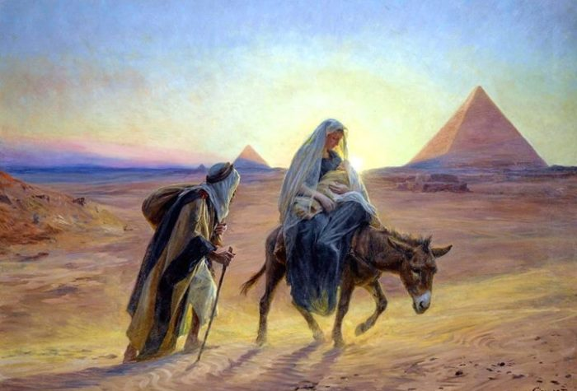

After Jesus was born and the wise men came and presented gifts to the new king, they were warned in a dream to depart from there a different way. Then, an angel of the Lord told Joseph and Mary that it was time for them to leave as well, so they fled to Egypt.
“And being warned in a dream not to return to Herod, the wise men departed to their own country by another way. Now when they had departed, behold an angel of the Lord appeared to Joseph in a dream and said, “Rise, take the child and his mother, and flee to Egypt, and remain there until I tell you, for Herod is about to search for the child, to destroy him. And he rose and took the child and his mother by night and departed to Egypt.” Matthew 2:12-14

Then tragedy struck. Herod was furious that he could not kill the king of the Jews who had been born, so he decided to eliminate the threat to his power and kill every child under two in the whole region around Bethlehem.

“Then Herod, when he saw that he had been tricked by the wise men, became furious, and he sent and killed all the male children in Bethlehem and in all that region who were two years old or under, according

to the time that he had ascertained from the wise men. Then was fulfilled what was spoken by the prophet Jeremiah: (Jeremiah 3:15) ‘A voice was heard in Ramah, weeping and loud lamentation, Rachel weeping for her children, who refused to be comforted because they are no more’” Matthew 2:16-18

What does this prophecy from the book of Jeremiah that is quoted in the book of Matthew, as he is describing the birth of Jesus, have to do with Rachel, the beloved wife of Jacob, who lived many years before, as told in the book of Genesis?

“When Jacob’s tribe were still some distance from Ephrath, Rachel went into labor, and she had hard labor. So Rachel died, and she was buried on the way to Ephrath (which is Bethlehem) and Jacob set up a pillar over her tomb. It is the pillar of Rachel’s tomb, which is there to this day.” Genesis 35:16, 19-20.

The description of the nativity that Matthew recounts which includes Rachel weeping for the children that Herod kills points back to the history of the Jewish people as told in Genesis where Rachel dies in childbirth in Bethlehem. Matthew is contrasting that sad event with the joy that God would now bring as he restores His people to their land, and eventually would make a New Covenant with His people through the promised Messiah. In other words, out of misery, there shall come joy!

“Behold, the days are coming, declares the Lord, when I will make a new covenant with the house of Israel and the house of Judah. For this is the covenant that I will make with the house of Israel after those days, declares the Lord. I will put my law within the house of Israel after those days, declares the Lord: I will put my law within them, and I will write it on their hearts. And I will be their God, and they shall be my people. And no longer shall each one teach his neighbor and each his brother, saying ‘Know the Lord,’ for they shall all know me, from the least of them to the greatest, declares the Lord. For I will forgive their iniquity, and I will remember their sin no more.” Jeremiah 31:31, 33-34.

In this Jeremiah prophecy in Scripture, both the promise of the coming King and the lament of Rachel over the dead children are prophesied, both of which take place in or near Bethlehem.

As we once again read the Christmas story in Matthew, it shows us the powerful intersection of the Old and New Testaments and how the Scriptural narratives are so interconnected. The prophet Jeremiah lived long before the Christmas story took place, and yet he so vividly foretells an important part of the narrative and what it means for our Christian faith.

Youth Christian Education Update

Our Youth Education program has had a very busy fall and early winter. Our team of teachers continues to provide Christian education to our youth, which is specifically designed to be both relevant to their daily lives, while being appropriate for their age.

We were delighted to re-introduce a nursey school program for our youngest parishioners in early November. Erika Santos has kindly agreed to serve as teacher for our nursery aged children, which hopefully gives the parents a break to attend our church services in relative peace and quiet!

With Erika fulfilling her new nursery school role, Ingrid Richards and Tiffany Woodberry serve as our pre-K and elementary school aged teachers. Our goal is to introduce our younger students to the key Christian principles, but do so in an environment consistent with their age.

George O’Hanlon continues to teach our middle school children through a program called Rite 13. This is a two-year program which culminates in a celebration at the 10am service, in which the candidates go through a special ceremony to acknowledge that they are becoming young adults. The program incorporates key elements of Christian concepts, such as the origins and content of faith, the importance of charitable works and the way which we see God and Jesus, and ourselves in that image.

Lauren Reid teaches our high school aged students, who are also the senior members of our Youth Education program. Lauren addresses key issues facing our high school aged students, and how Christian principles provide guidance and help in addressing them.

We remain proud that our students are active participants in the 10am service, through serving as acolytes, ushers and lay readers. Look for us throughout the year in these roles.

A highlight for our year was the Annual Youth Christmas Pageant. This year was a special year because it was the first year we combined our Grace Church and LaGracia students. Our narrators and actors appeared as angels, shepherds, the 3 kings, Mary, Joseph and others, and once again brought us the Christmas story on December 24th. This Grace Church tradition has been a great success over the years, and we were delighted to include LaGracia as part of this tradition this year, and going forward. We hope that you attended and enjoyed our presentation!
George O’Hanlon

DAISY CALDERON
SENIOR WARDEN
By Tricia McGuinness
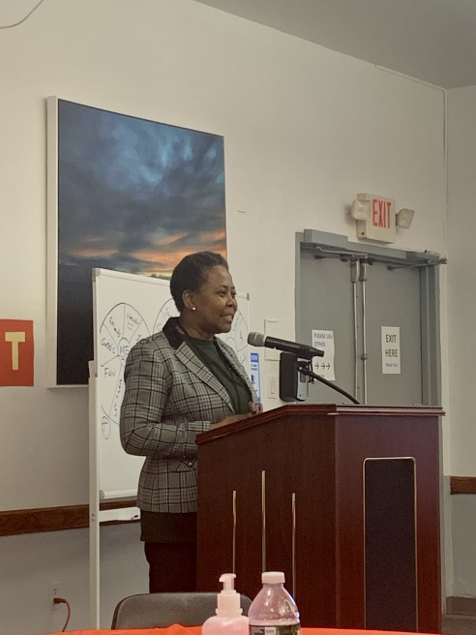

So many talented, generous souls put their efforts toward making Grace/LaGracia a place of sacred rites and human community – so very many. This is a piece about just one, a quiet woman who manages so many endeavors with talent and strength wrapped in her dedication to God and her community.

Daisy Calderon, our Sr. Warden, has been with Grace/La Gracia eight years. In that time she has
worked tirelessly with Fr. Aldofo to grow La Gracia in so many ways. That is ongoing. In our recent time of transition, Daisy negotiated a reasonable parting of Grace and Fr. Chip. While doing so, she got the Pew Project done for the need and beautification of Grace. While doing that, Daisy was coordinating with Fr. Adolfo on monthy meetings for La Gracia’s overall functioning and Grace Vestry meetings, organizing the toy drive (which she has done annually for some time) and even handling oversight of Building and Grounds for a time.

Daisy has been on the Grace vestry for 6 years and Sr. Warden for 2 years. She helps unite the two cultures of Graces. As a member of La Gracia, who often attends Grace services (her daughter Jackie handles the livestream for Grace each Sunday), Alicia Silva says: Over the last 5 years I have been a member, Daisy is always involved in any matter that pertains to La Gracia. La Gracia is truly blessed to have Daisy as a genuinely devoted follower of Christ.”

Throughout all her work for Grace/La Gracia, Daisy has worked as a financial advisor for a major Bank. She deals with high-net-worth foreign clients for the institution. And Daisy has 3 grown children living in different parts of the country and parents who visit frequently from Honduras.

We are grateful to Daisy for all her vital contributions to Grace/La Gracia. Thank you, Daisy.

Capturing the Holy Spirit

Submitted by Irene Alves and Sylvia Simon
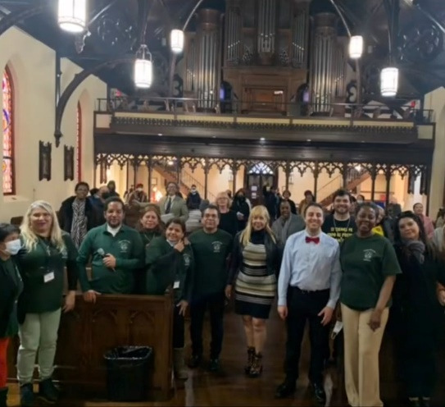

On November 19 and 20, approximately fifty parishioners of Grace, and a group from St Andrews Episcopal Church, attended a retreat in Grace Church, titled Life in the Spirit Seminar. The goals of this retreat were: 1) to help participants establish, reestablish or deepen an individual relationship with God through Jesus Christ. 2) to help participants yield to the ongoing presence of the Holy Spirit in their lives. 3) to realign our lives and put Christ at the center rather than on the periphery.
Fr. Adolfo led us on this faith journey. He and several other attendees shared their individual stories of faith and rebirth. This event was hosted by the La Gracia parishioners who organized the retreat and who were the ushers of this magnificent spiritual experience. The retreat included speakers, scripture, music, prayer and small discussion groups where parishioners were encouraged to share their spiritual journey and give their understanding of the different talks.
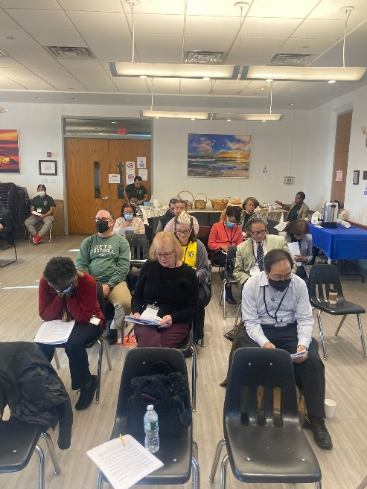
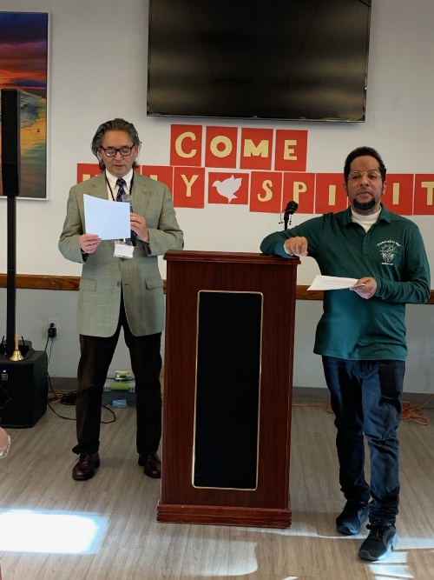

We also participated in singing soul stirring hymns which enhanced the positive spiritual reawakening. Finally, each individual attendee was enveloped in prayer as they sat and meditated in church on the final day. Everyone left the retreat with a renewed sense of faith and purpose. Fr. Adolfo plans to meet with the group periodically to discuss their continued faith journey.

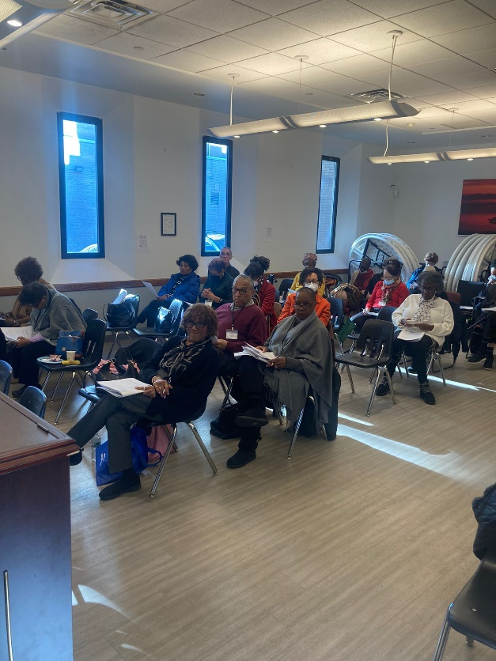

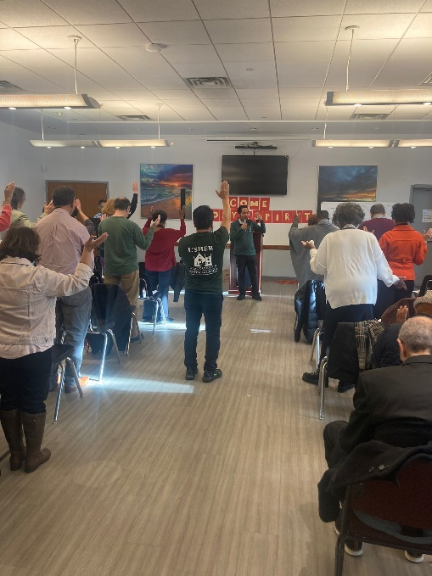

For those of who did not have the opportunity to attend the retreat on November 19-20, God willing, we will have another Life in the Spirit Seminar in the summer of 2023.
STEWARDSHIP 2022-23
The theme we chose for Stewardship 2023 is “The Good Shepherd Shares God’s Blessings”. This theme was chosen because of the many blessings we received in 2022. Just to name a few: Father Adolfo was named our Priest in Charge; our church and sacristy were completely refurbished by a generous donor; our Sunday School has reopened and our children have returned to classes. And just recently we had a fantastic spiritual retreat that was attended by some 50 parishioners from Grace and St Andrews Churches with LaGracia parishioners attending as ushers, spiritual helpers, and musicians.

Every Sunday we have the opportunity to pray together and receive a blessing. Father Adolfo has a special time at the end of the service during which we are asked to put everything aside, open our hearts and minds, and he says “Come Holy Spirit, Come”. Have you felt the blessing? Have you felt the Holy Spirit come into your life? We receive blessings from the good shepherd. What do we do when we receive it? How does it affect the time, talent and fortune that you pledge to Grace LaGracia?

In Psalm 24:1 we are told that the earth is the Lord’s. So all that we have belongs to the Lord. God blesses us with abundance and we have the responsibility to handle what God has given to us. We must then be accountable for how we steward what he provides.

There are many ways that each of us can share the blessings that we have received from the Lord. But first we have to manage what has been given to us. Please read the parable of the talents (Matthew 25 14-30). Then we can share our blessings by being hospitable (soup kitchen, welcome committee, choir, stewardship committee, etc), by sharing our wealth (pledge, organ fund, music fund, etc), engaging in prayer (retreat, Bible study, home prayer, praying by phone or internet etc.) and/or giving service (vestry, acolytes, welcome committee, ushers, choir member, etc). In turn, God will reward you for being a good shepherd.

Your vestry realizes that Grace LaGracia has been blessed in 2022 with the appointment of Father Adolfo as The Priest In Charge. The vestry has developed a budget which has lowered expenses by: decreasing the amount paid for staff salaries, office supplies, Con Ed and music. Your vestry has been very responsible and is acting as a good steward.

Pledge Sunday was November 6th. Many members pledged on this or subsequent Sundays. Have you pledged? The front of the form asks for the amount of money that you can pledge weekly, monthly, bi monthly, quarterly or yearly. On the back of the pledge form there is a list of the committees that you may wish to join and the service you can donate to our church. Please consider joining the vestry as your service. Let us remember that we have received the Lord’s blessing and we are now giving back to God what is His. We encourage everyone who is able to, to increase their pledge for 2023.

Please remember that if you are giving weekly and if you don’t attend on a particular Sunday, you should give 2X the amount on the third Sunday. In other words, whether you are giving weekly or monthly or yearly, the end result at the end of 2023 is the same amount.

If you have a question, please contact Charlotte Roberson, Chairperson (until 1/23) (crobers8975@gmail.com or 917-842-4548 or Andrea Spencer, Chairperson(after1/23) (dreaspencer@aol.com or 845-729-2151.
Charlotte Roberson

MAYORDOMIA 2022-23
El tema que elegimos para la campaña de Mayordomía del 2023 es “El buen pastor comparte las bendiciones de Dios”. Este tema fue elegido debido a las muchas bendiciones que recibimos en 2022. Solo por nombrar algunas: el Padre Adolfo fue nombrado nuestro Sacerdote a cargo; nuestra iglesia y sacristía fueron completamente renovadas por un generoso donante; nuestra Escuela Dominical ha reabierto y nuestros niños han regresado a clases. Y recientemente tuvimos un retiro espiritual fantástico al que asistieron unos 50 feligreses de las Grace Church y St Andrews con feligreses de LaGracia que asistieron como ujieres, ayudantes espirituales y músicos.
Todos los domingos tenemos la oportunidad de orar juntos y recibir una bendición. El Padre Adolfo tiene un momento especial al final del servicio en el que se nos pide que dejemos todo a un lado, abramos el corazón y la mente, y nos dice “Ven Espíritu Santo, Ven”. ¿Has sentido la bendición? ¿Has sentido el Espíritu Santo entrar en tu vida? Recibimos bendiciones del buen pastor. ¿Qué hacemos cuando lo recibimos? ¿Cómo afecta el tiempo, el talento y la fortuna que prometes a Grace La Gracia?
En el Salmo 24:1 se nos dice que la tierra es del Señor. Así que todo lo que tenemos pertenece al Señor. Dios nos bendice con abundancia y tenemos la responsabilidad de manejar lo que Dios nos ha dado. Entonces debemos ser responsables de cómo administramos lo que él nos proporciona.
Hay muchas maneras en que cada uno de nosotros puede compartir las bendiciones que ha recibido del Señor. Pero primero tenemos que administrar lo que se nos ha dado. Por favor lea la parábola de los talentos (Mateo 25 14-30). Entonces podemos compartir nuestras bendiciones siendo hospitalarios (comité de bienvenida, coro, comité de mayordomía, etc.), compartiendo nuestro tesoro (promesa, fondo de órgano, fondo de música, etc.), participando en la oración (retiro, estudio bíblico, hogar oración, rezar por teléfono o internet, etc.) y/o prestar servicio en (junta parroquial, acólitos, comité de bienvenida, ujieres, miembro del coro, etc.). A su vez, Dios te recompensará por ser un buen pastor.
La Junta Parroquial reconoce que Grace / La Gracia ha sido bendecida en el 2022 con el nombramiento del Padre Adolfo como El Sacerdote Encargado. La junta parroquial ha desarrollado un presupuesto que ha reducido los gastos al: disminuir la cantidad pagada por los salarios del personal, suministros de oficina, Con Ed y música. Su junta parroquial ha sido muy responsable y está actuando como un buen administrador.
El domingo de promesa fue el 6 de Noviembre. Muchos miembros se comprometieron en este domingo o en los siguientes. ¿Te has comprometido? En la parte frontal del formulario se solicita la cantidad de dinero que puede prometer semanal, mensual, bimensual, trimestral o anual. En el reverso del formulario de compromiso hay una lista de los comités a los que puede desear unirse y el servicio que puede donar a nuestra iglesia. Por favor considere unirse a la Junta Parroquial como un servicio a la Parroquia. Recordemos que hemos recibido la bendición del Señor y ahora estamos devolviendo a Dios lo que es suyo. Animamos a todos los que puedan, a aumentar su promesa para 2023.
Recuerde que si dona semanalmente y no asiste un domingo en particular, debe donar el doble de la cantidad el tercer domingo. En otras palabras, ya sea que esté donando semanalmente, mensualmente o anualmente, el resultado final a fines de 2023 es la misma cantidad.
Si tiene alguna pregunta, comuníquese con Charlotte Roberson, presidenta (hasta el 23/1) (crobers8975@gmail.com o 917-842-4548 o Andrea Spencer, presidenta (después del 23/1) (dreaspencer@aol.com o 845-729 -2151.
Charlotte Roberson

PHILOSOPHY TEST SKILLS

It was the last day of philosophy class, and time for the final exam. The professor had exposed the students to several schools of philosophy during the semester. He looked out over them as they sat and waited expectantly. Finally, he pointed at his desk and said, “I have only a single question on this final test. Use anything I have taught you this year to prove to me this desk does not exist.”

Immediately the students started writing furiously, filling pages and pages of exam books with proofs for the non-existence of the desk. One girl, however, wrote for a few seconds, gathered her books, walked to the front of the class, turned in her exam book, and was out of the classroom in two minutes.

When the professor posted the grades the following Monday, only one person had received an A. It was the girl who finished the exam so quickly.

Her answer: “What desk?”

Our Lady of Guadalupe

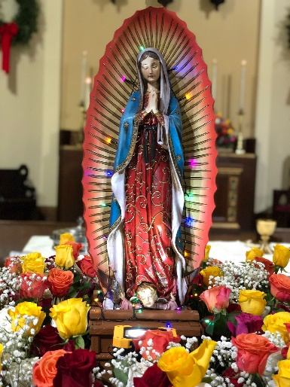

By Rev. Adolfo Moronta

Our Blessed Mother Mary is known by many different titles (Blessed Mother, Madonna, Our Lady), epithets (Star of the Sea, Queen of Heaven, Cause of Our Joy), and other names such as Our Lady of Loreto, Our Lady of Guadalupe, Copacabana, … In our Book of Common Prayer (p.864) she is mentioned as “Mary the Virgin, the God-bearer (Theotokos).”

All of the titles Mary bears refer to the same individual named Mary, the mother of Jesus and are used variably by all who have a devotion to her. In Latin America the figure of Mary arrived with the Spanish conquest, when indigenous peoples were evangelized and converted. Conquered peoples later embraced her not as a Patron of their conquers but as the “mother of God,” who stands with those suffering oppression and discrimination. Throughout Latin America and in the faith of Spanish-speaking Episcopalians, Mary is widely recognized and is an important part of the faith.

The Virgin of Guadalupe is the most familiar and common devotions of Mary in Latin America. This representation comes from an appearance of Mary to an indigenous farmer in the 16th Century in Mexico. He found this image miraculously imprinted on his peasant garment, and it is still on display in a church in Tepeyac, Mexico. The rays in the background symbolize an Aztec deity which is being eclipsed by Mary. She is wearing a black cincture which, at the time, symbolized pregnancy.

The Blessed Mother of Guadalupe holds a special place in the religious life of Mexico from where 80% of the parishioners of La Gracia come. Her image has played an important role in Mexican history but is not limited to religious matters; she has also played an important function in Mexican nationalism and identity.

The celebration of Our Lady of Guadalupe took take place on December 11 at 7:30 PM. 150 parishioners were present for this event. The festivity had three major moments: a) the procession outside the church which was done together with a Mariachi Band b) the Eucharist and c) the Mañanitas that consist of waiting until 12:00 AM, the hour in which the Mañanitas sing to the Virgin of Guadalupe.

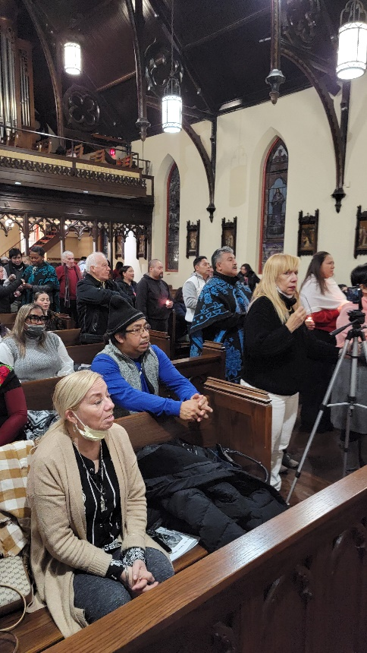

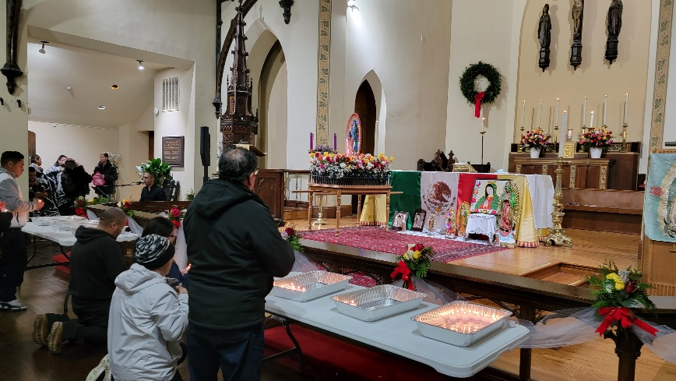

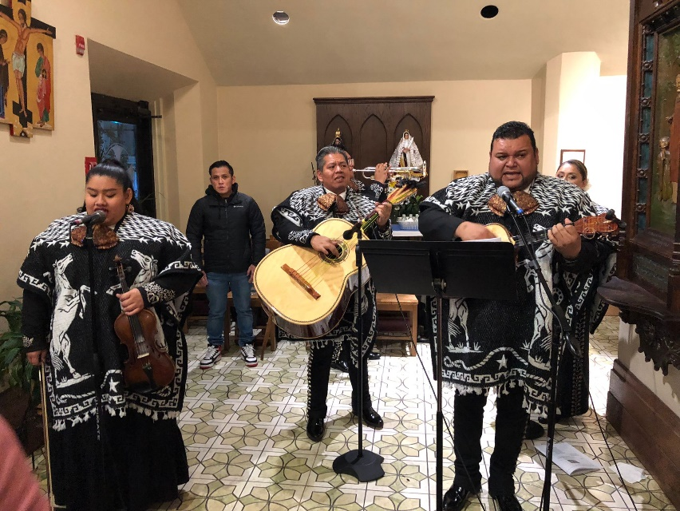

THANKS TO THOSE WHO SERVED ON THE VESTRY

I want to take this opportunity to publicly thank the three Vestry members whose terms are ended this past year:
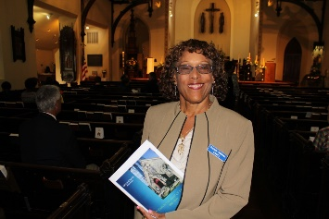
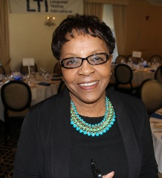

Sylvia Simon Irene Alves Charlotte Roberson

Being a Vestry member is a lot of work. It is exhausting, frustrating, but also enlightening and rewarding. Every Vestry faces unique challenges and every person who has ever served on a Vestry has given up a lot of time and effort to serve the church and its parishioners.

I am proud of the things we accomplished in a year that presented many challenges. I feel it’s important to hear and discuss ideas and work hard to find solutions. That is what makes a Vestry effective. This Vestry worked very hard and accomplished many things that are easy to see and others that are very much behind the scenes.

While I take this moment to thank and recognize these three individuals, I also want to say thank you to the Vestry members who will be serving for the next term. But in addition, I feel it’s important to encourage all parishioners and members to consider offering your time and talent to the benefit of the church. Running for and serving on the Vestry is one way to do that, but there are many other opportunities to serve. Our committees always need volunteers and individuals who can offer ideas and talents to the benefit of the church.

There are a lot of talented people here at Grace/La Gracia and we can use all those talents. This is our spiritual home and we are all neighbors and family, working together we will maintain Grace/La Gracia as a dynamic and welcoming parish.

Once again, let’s all give thanks for the service of Sylvia Simon, Irene Alves and Charlotte Roberson to Grace/ La Gracia.

In Christ, Fr. Adolfo

ANNUAL CONGREGATIONAL MEETING
and
ELECTION OF NEW VESTRY MEMBERS

The annual meeting of the congregation will be held on Sunday, January 29, 2023. It will be held directly following the bi-lingual service at 11:00 a.m. An important part of that meeting is to elect new members of the Vestry who will each serve a three-year term of office. In order for each voter to be prepared to make an informed selection, the following profiles have been presented by the candidates. The candidates for this important parish office are: Sorraya Sampson Elliott, Eileen McClean, George O’Hanlon, and Marisol Ortega.

Sorraya Sampson Elliot
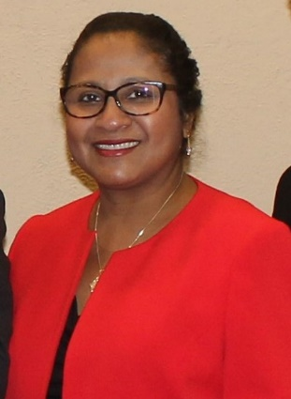

I have been a member of Grace Church since 1978 and was raised in Grace Church where I received my first communion, confirmation and was married. Both my children, Ashley and Christopher, served as acolytes at the 10:00am service before going off to college.
I previously served two terms on the Vestry, serving as the Vestry-Clerk for several years. I also served as the Nominating Committee chairperson. As the Co-Chair of the Advocacy Committee I organized the "What to do if stopped by the police " forums and the voter registration events which took place after the 10:00 am and 12:30 pm services in both Spanish and English. The committee also organized a voter registration drive that was held on a weekday for the individuals who received lunch from LUW. Information was provided regarding the new rules allowing ex-offenders to vote.
When not at Grace Church, I serve the community as the first woman appointed as President & CEO of the Urban League of Westchester County, Inc.
I hold a Masters Degree in Management and Policy from Stony Brook University, a Bachelors Degree in Economics and a Bachelors Degree in the Integrated Social Sciences of Anthropology, Sociology and Psychology.
My years of professional experience in not for profit management embodies my devotion to community service and improving the socio-economic position of marginalized populations. I live in White Plains.

Eileen McClean

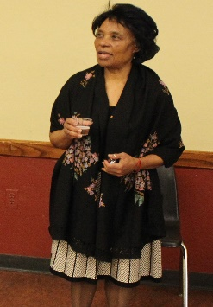

My name is Eileen McClean. I have been a pledging member of Grace Church since 1974.
I am currently finishing a term as Junior Warden and I am seeking consideration for re-election.
I have served two 3yr. terms on the vestry. I have served on the search committee for organist. I have been actively involved in the following: member of the choir for many years, member of the ECW, member of Ministries to the Caribbean, organized and hosted 2 concerts (Lenten Concert and the Mozart Requiem) as fund raisers to support the Organ Fund. I have served as a voting delegate representing Grace Church at the annual Diocesan Convention.
I am currently a Lay Eucharistic Visitor, Lay Reader, Chair of the Music Committee, Chair of the Welcoming Committee. Served as committee chair for the Barbeque held Sept. 18th
In my personal life I am currently employed in Health Care as Associate Director of Peri-Op Services My goal is to work closely with the Vestry and Clergy as we face the many challenges especially those of Growing the Church membership, and supporting Grace Church in our Parish community. I consider Grace Church to be my spiritual home.

George O’Hanlon
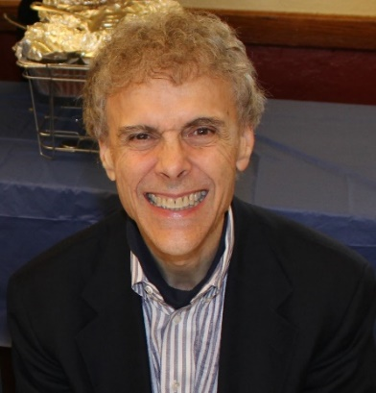

My name is George O'Hanlon and I am running for the Grace Church vestry. I am seeking this role because I believe that Grace Church is at an inflection point. We've just come through a difficult period brought on by the pandemic and some changes in our senior leadership. These events are now largely behind us. I believe Grace Church is poised for growth. The vestry will have a key role in achieving this objective, both in setting a vision, and working to achieve it. It is my sincere hope to work as a member of the vestry to help bring about this outcome. My family and I have been actively engaged at Grace Church since 2005. I currently serve as the Youth Education Director at Grace Church, having been a Primary and Rite 13 teacher for many years. I take particular pleasure in seeing our younger parishioners grow through our youth education program. All three of our children participated in this program from the primary school level through high school. You have likely seen them as acolytes, ushers or participants in our annual Christmas Pageant. I have also been active in our Grace Kitchen volunteer work, as an usher and in various other Church capacities over the years. Professionally I have been a lawyer for 40 years — 39 as in house legal counsel for IBM and 1 with an IBM spinoff called Kyndryl. I enjoy reading and running. My wife Karen and I live with our 3 children in White Plains.
Marisol Ortega

Hello members of Grace Church/LaGracia. My name is Marisol Ortega. I was welcomed to the church upon returning to the country when I was seven years young. The most foundational years of my life I spent alongside the many members who make this church the warm and nurturing place of worship it continues to be. I served as an acolyte for eleven years and as a vestry member.
I have been an educator for nine years, currently teaching English at Sleepy Hollow High School. I also coach Sleepy Hollow Middle School's Cheerleading Team, which has been a passion of mine for several years. Being a coach to our youth has been a rewarding opportunity, an opportunity to be the adult that our children need, one who is responsible, empathetic, understanding, compassionate, and, most of all, encouraging. The encouragement I received in Grace Church / La Gracia remains unparalleled. I am eternally grateful for my Grace Church Family and look forward to being granted more opportunities to serve our community.

Lent
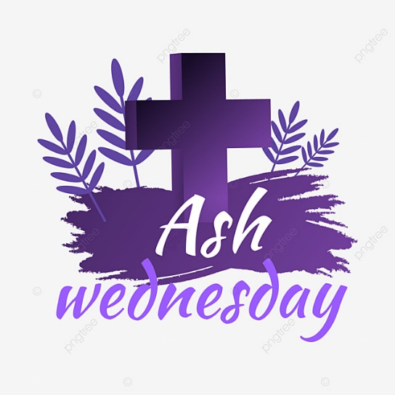

Lent, is a period of penitential preparation for Easter. It begins on Ash Wednesday; (in 2023 Ash Wednesday will take be on February 22). Lent begins six and a half weeks before Easter, and provides a 40-day period for fasting, abstinence (Sundays are excluded), prayer and almsgiving in imitation of Jesus Christ’s fasting in the wilderness before he began his public ministry. Lent ends at sundown on Maundy Thursday.
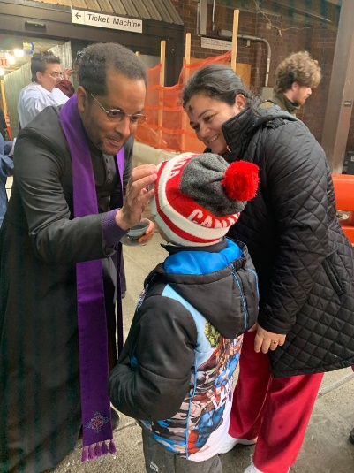

In the Anglican churches The Book of Common Prayer prescribes that Lent be observed with fasting. In Lutheran and many other Protestant churches, Lent is observed with various services and practices, though Lent is not formally observed in many Evangelical or nondenominational churches.
Additionally, Lent is a time also to prepare ourselves for the Lord's Resurrection at Easter. During Lent, we seek the Lord in prayer by reading Sacred Scripture; we serve by giving alms; and we practice self-control through fasting. We are called not only to abstain from luxuries during Lent, but to a true inner conversion of heart as we seek to follow Christ's will more faithfully. We recall the waters of baptism in which we were also baptized into Christ's death, died to sin and evil, and began new life in Christ.
In Lent we are also called to practice self-discipline. In addition, the giving of alms is one way to share God's gifts—not only through the distribution of money, but through the sharing of our time and talents. As St. John Chrysostom reminds us: "Not to enable the poor to share in our goods is to steal from them and deprive them of life. The goods we possess are not ours, but theirs."
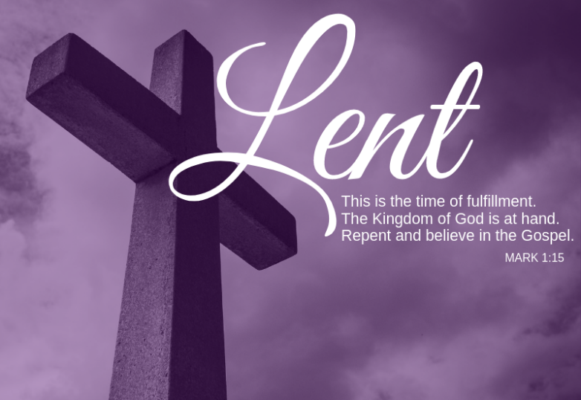

HOME SWEET HOME

Stable, adequate housing is a critical foundation on which all other individual and family success can be built.

2022 was the 5th year that Lifting Up Westchester sponsored a writing contest for youth from grades 7 through 12 who attend schools in Westchester. That essay contest invited students to think about the role housing plays, not only in our individual futures, but the future of our community. Students were asked to consider how the Pandemic exacerbated this problem for a much broader socio-economic group who have lost jobs or had salaries reduced at the same time rents and mortgages have risen faster than income and earnings. The students were asked to consider how we can help ensure adequate housing for all of our neighbors.
In last summer’s issue of the Angelus, the winning essay in the 7th and 8th grade category was printed as well as the second-place winning essay by a student who happens to be familiar to Grace because Kendal Mangum is the granddaughter of Walter and Sylvia Simon. In last fall’s issue, we printed the other winners in the 9th and 10th grade category and 11th and 12th grade category. In this issue, we are printing the essay in the English as a Second Language category.

Angelus readers can greatly profit from reading what these talented young people have written about this important topic. It might be profitable for each one of us to think about how we might respond if we were asked to discuss the topic of Home Sweet Home – when Home isn’t so Sweet!

We are always hopeful that the 2023 contest will inspire some of our own young parishioners to enter the newest contest that is now being offered.

Housing: It Determines Your Future
By Hirokatsu Tao, 11th Grade
English As a Second Language

I am a Chinese student attending a private Japanese boarding school in Westchester County. Crazy, right? Even crazier, most of my schoolmates live the lavish lifestyle you see in "Crazy Rich Asians." Although not on the same economic level as my peers, I am privileged enough not to have to worry about food on my table, a roof over my head, and a good education. These are concerns many of my neighbors in Westchester are burdened with due to the issue of unstable housing. As a Westchester resident for only two years, there are still many things to learn about my community. With my unique perspective, I hope first to tackle the housing issue.

The root of unstable housing is poverty. Westchester is an affluent area highlighted by a significant wealth gap between the rich and poor. According to the Census Bureau, the highest-earning fifth of households in Westchester makes $341,544 on average, 20 times that of the bottom fifth. In other words, many impoverished locals are hiding under the facade of "The Westchester" mall, gated communities, and fancy houses. This disparity in wealth is exceeded only by a few areas within the U.S.
Hiding poverty under the facade of status is also true for Hong Kong. However, Hong Kong has what Westchester lacks most, an effective government program dealing with housing. The rent assistance scheme of Hong Kong provides either 25% or 50% rent reduction for public housing tenants facing financial hardship. Programs like this hinder the growth of poverty. With fewer safety nets and government programs that deal with housing, Westchester has a high poverty rate. Additionally, with a population seven times that of Westchester, Hong Kong had a homeless population of around 1,500 in 2021. This number was 300 less than the 1,800 individuals living without a roof over their heads in Westchester County.

The COVID-19 shutdown aggravated the poverty situation in Westchester. Entire industries faced cessation, and millions of people went out of work or had their salaries reduced. Countless households had problems concerning their tenancy. In some cases, residents were kicked out of their homes because they could not pay the increased rent or mortgage. This shutdown also stopped new housing from being built, resulting in a low housing inventory all over the U.S. Combining this with the recent trend of working from home, suburban areas like Westchester now face increased demand for housing. The economic and social disruption caused by the unprecedented madness of COVID-19 leaves poor locals priced out of the few available homes.

Considering all these factors mentioned above, what would my future look like if I decided to stay in Westchester after I graduate from college? With an appreciable resume and the support of my family, I could probably afford a decent apartment and find a 9-5 job. However, I am privileged enough to disregard the wealth gap and effects of the pandemic. The 1,800 homeless individuals and the tens of thousands of Westchester residents facing unstable housing cannot do the same. Often not even self-induced, these unlucky disadvantages limit their potential and futures.

Unable to pay their rent, one result for households facing unstable housing is to look into the sharing economy. This sharing economy would mean to either couch-surf or stay with another family. These options would not be a long-term solution, however. Couch-surfers and people living in overcrowded quarters suffer from mental and physical stresses due to their unstable living arrangements. They may not have the ability to maintain good hygiene, which spreads illness such as COVID-19. Plus, they often face food anxiety. Additionally, the adverse effects on children due to inadequate housing are detrimental to their development. Hidden dangers like sex abuse have scarred countless young people in the past. Although there is no official statistic for this, reports show that upwards of 60% of young female couch-surfers have fallen victim to sexual abuse. On top of handling the numerous pressures of an unstable living condition, they have to go to school. Without special attention and understanding from their teachers, it would be impossible to keep up with their studies. For these children, going to college is the last of their priorities. If I were a kid forced to couch-surf, I would be tired of the struggles. I would quit school, join a gang, and turn to a life of crime. Indeed, many teenagers make this same decision. Studies show that low-income and inadequate housing leads to increased crime.

Not only is this outcome going to destroy one's future, but the community suffers when too many people struggle with unstable housing and homelessness. Having some of our neighbors in risky living situations creates unpredictability for all of us. The community becomes unsafe. Increased security costs, lack of trust between neighbors, and an overall unpleasant atmosphere will become a reality within the community.

As seen, housing is an issue we cannot ignore. Adequate and stable housing is paramount to the futures of ourselves and our community. That being said, it is our responsibility to help out those who cannot fulfill this need themselves. Organizations like Lifting Up Westchester have already created methods to aid those in need. Numerous types of shelters have been set up. Life skills training, health & wellness support, and employment assistance are offered to help people buy the house they have always wanted. Summer camps, mentoring services, and scholarships are given to the youth to steer them clear of the tempting path of crime, giving them a chance at a bright future. With social services like Lifting Up Westchester already doing their part, it is our turn as individuals to help. So, you might ask, "What can I do?" I'm not asking for much. Next time you pass by someone living on the street, take a moment before you look away. Appreciate the fact that you have what they don't; feel privileged. Who knows, you might even be motivated to volunteer or donate and help Lifting Up Westchester.

LIFTING UP WESTCHESTER 2023 YOUTH ESSAY CONTEST

GET YOUR KIDS INVOLVED

Our annual essay contest is right around the corner! Created by Hannah Nelson, LUW board member, in memory of her sister Beth Massey Rubens, a lifelong teacher, tutor, and mentor who had a love for language arts, our essay contest encourages students to reflect on LUW’S mission.

The contest is open to all students grades 7-12 who live in or attend school in Westchester County.
This year’s topic centers around mental health and how to end the stigma attached to mental
health and homelessness.
Go to www.liftingupwestchester.org for more information.

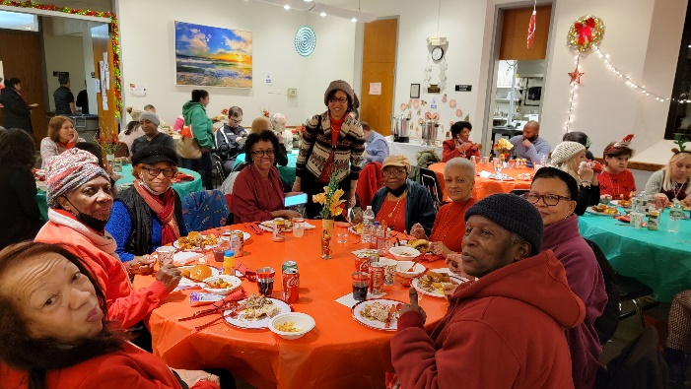
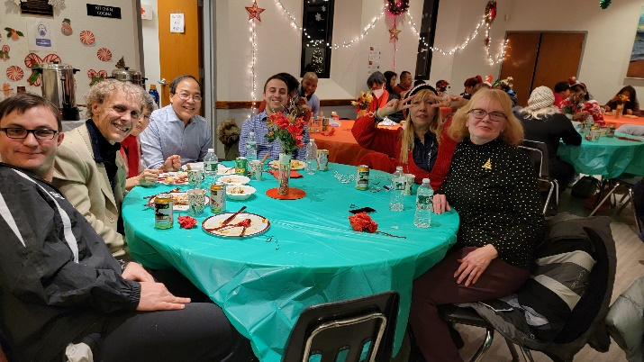
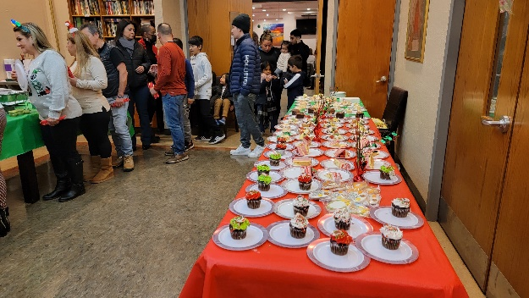
SCENES FROM THE CHRISTMAS DINNER

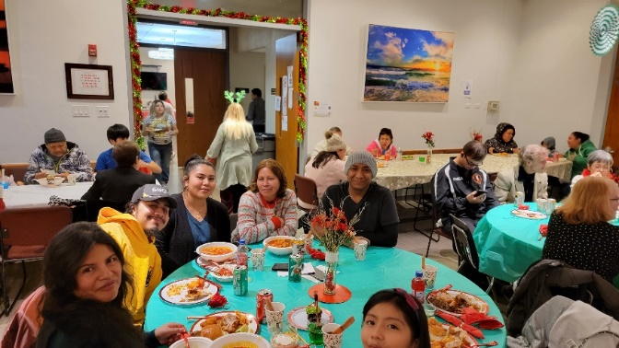

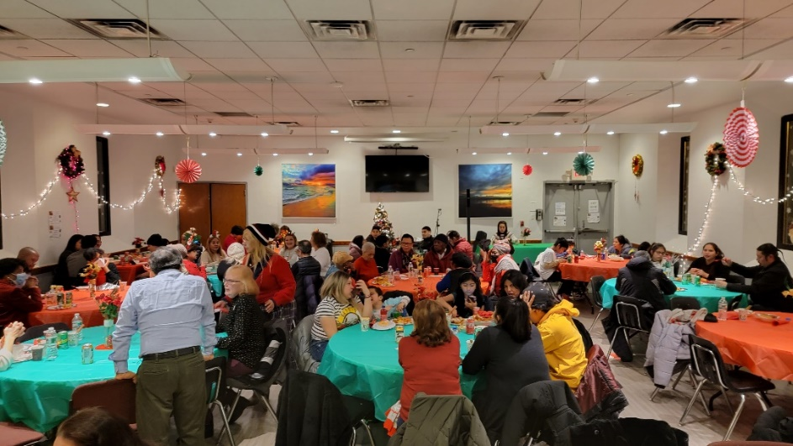

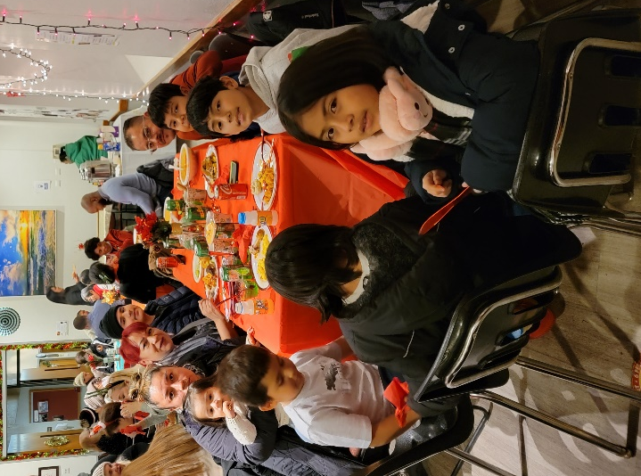
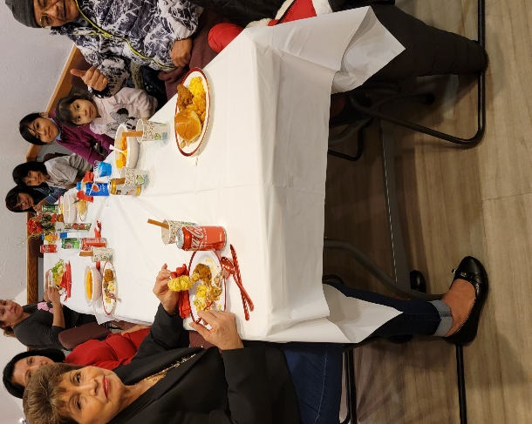

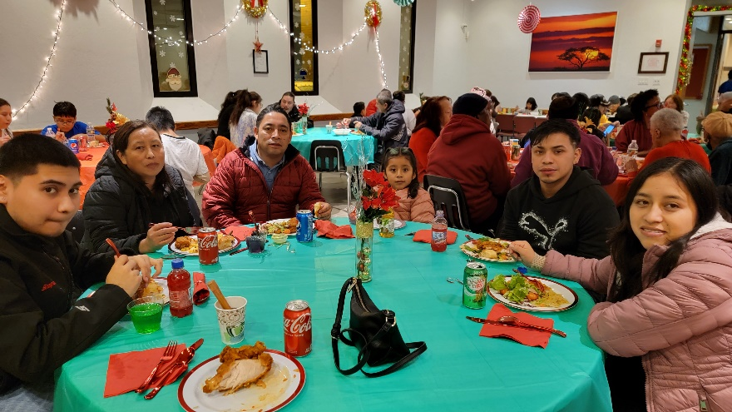

REST IN PEACE

Almighty God, Father of mercies and giver of comfort; Deal graciously, we pray, with all who mourn; that, casting all their care on you, they may know the consolation of your love; through Jesus Christ our Lord. Amen.

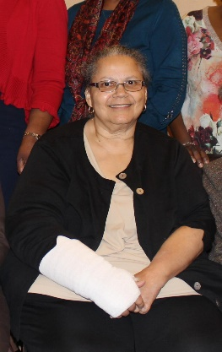

Cynthia Cole

Nellie Alexander King Bob Hamlyn

The Angelus
Quarterly Newsletter
of Grace Church/La Gracia
(914) 949-2874
www.gracewhiteplains.org

Priest in Charge: The Reverend Adolfo Moronta

Editor: Mary Baker

Contributors: Mary Baker, George O’Hanlon, The Rev. Adolfo Moronta, Sylvia Simon, Irene Alves, Trisha McGuinness, Karen Odom, Charlotte Roberson

Distributor: Suzan Ortega-Collado

